Ideas & Activities to promote writing for Primary-aged children

There are lots of ways to make writing fun and meaningful at home! Here are a few ideas you could try:
- Help your child write a letter to their favourite author. Correspondence can often be sent to an author’s publisher (whose details can be obtained on the internet) who will pass it on.
- After making a cake or doing a craft activity, challenge children to write the recipe or instructions for someone else to use.
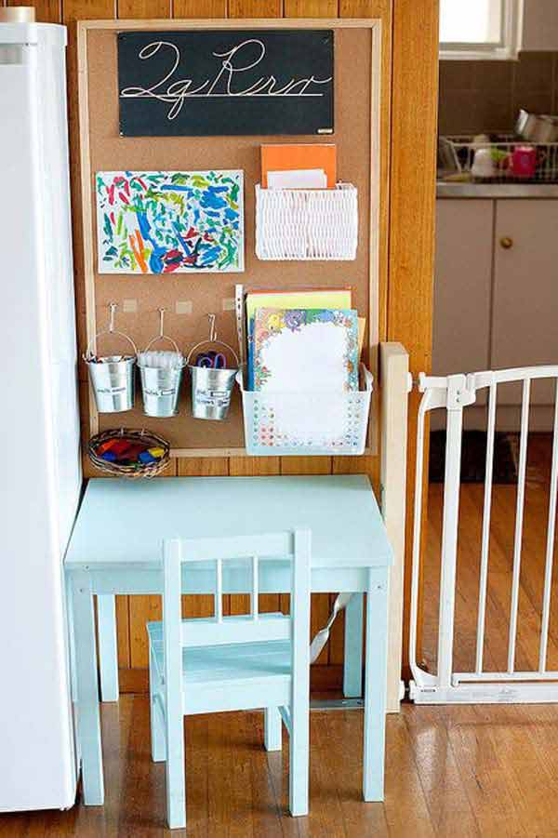
- Let your child write their own Christmas cards, invitations, thank you letters, cards or e-mails to friends or relatives. Invite them to help you write the shopping list or to record game scores.
This Photo by Unknown Author is licensed under CC BY-SA
- Create silly sentences or tongue twisters using alliteration (a group of words that all begin with the same sound) e.g. Silly Sam swam the smelly swamp
- Make writing special by providing a variety of ‘cool’ pens and pencils, envelopes, stampers and put their writing on display around the home.
- Cut out words from a newspaper or magazine. Can they use the words to write a sentence?
- Help them to organise and sequence their writing by asking them to talk about their ideas or to draw a sequence of simple pictures to show how the main events in a story might be organised.

Word-building games
Games are a great way to bond and to learn a whole range of skills, including turn-taking, counting, using vocabulary to describe or developing a strategy to win. Here are some ideas of games that aid word-building or vocabulary, which in turn will improve writing skills:
- Scrabble – now available in several versions, including ‘Junior’, ‘Harry Potter’
- Boggle
- Guess Who (developing descriptive vocabulary)
- Up Words
- Charades
- Headbandz
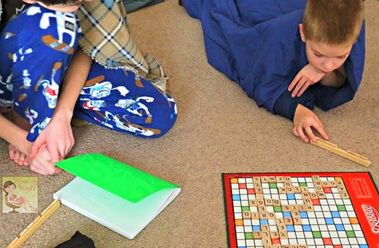
This Photo by Unknown Author is licensed under CC BY-ND

Writing Competitions

The Canterbury Tales writing competition is open to 5-18-year olds and the 2021 theme is ‘be careful what you wish for’! Children can choose to enter a story, a poem or a character description and the deadline is 31st January 2021. Click here
for more information.
Keep your eye out on our website for other competitions!

Here for you
If you’d like more ideas or advice to support writing for the child that you’re fostering, feel free to contact Sara Martin, Early Years and Primary Specialist at Sutton Virtual School on sara.martin@cognus.org.uk.

