Writing Ideas & Activities for Early Years children
What activities can we do at home to help improve writing readiness (pre-writing) skills?
We asked the Early Years team at Cognus for some activities you could try at home with your pre-schoolers. Here are their suggestions:
- Building up strength in the shoulders, arms and wrists by waving scarves, gentle weight-lifting with small bottles filled with water (can they lift them above their heads?)
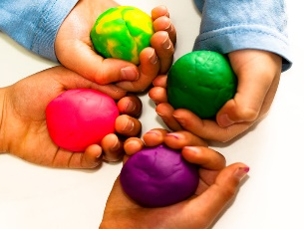
- painting surfaces outside with large decorating brushes to get the big sweeping movements (water on walls works well!)
This Photo by Unknown Author is licensed under CC BY-NC-ND
- Playdough is brilliant - squeezing and squashing it to strengthen wrists and hands. Mark-making in sand or cornflour with tools, fingers, sticks.
‘Physical activities and big movements support children to develop their readiness to write.’

‘Physical activities and big movements support children to develop their readiness to write.’

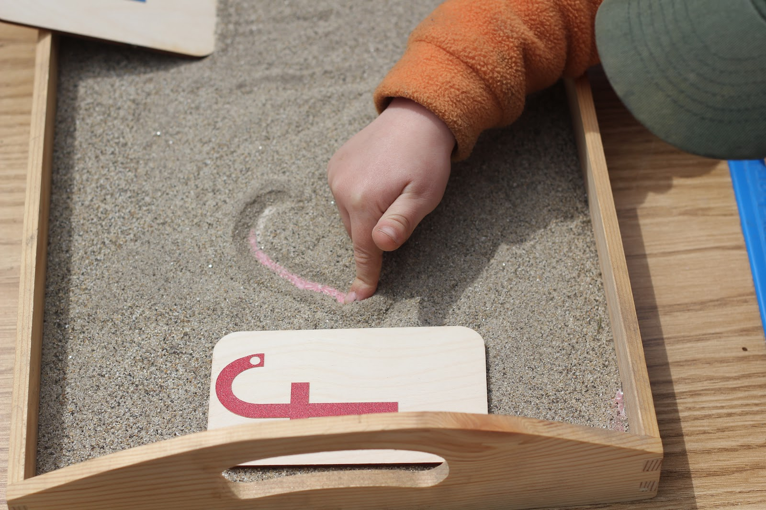

Here are some more activities you could try at home:
- Can they write their own name on paper? Explore practising this using other materials, such as mark-making in sand, paint, mud etc
- Scissor projects: cutting out shapes, along lines or in activities like this robot-making template
- Using tongs or teabag squeezers to pick up objects
- Developing finger strength in everyday activities, such as opening jars, door handles and using light switches
- Pre writing shapes: practising drawing the pre-writing shapes (l, —, O, +, /, square, \, X, and Δ)
- Junk modelling: making things using old boxes, egg cartons, wool, paper and sticky or masking tape.
- Construction: Building with duplo, lego, or other construction toys.

Learning through play
Tiny Happy People At Home:

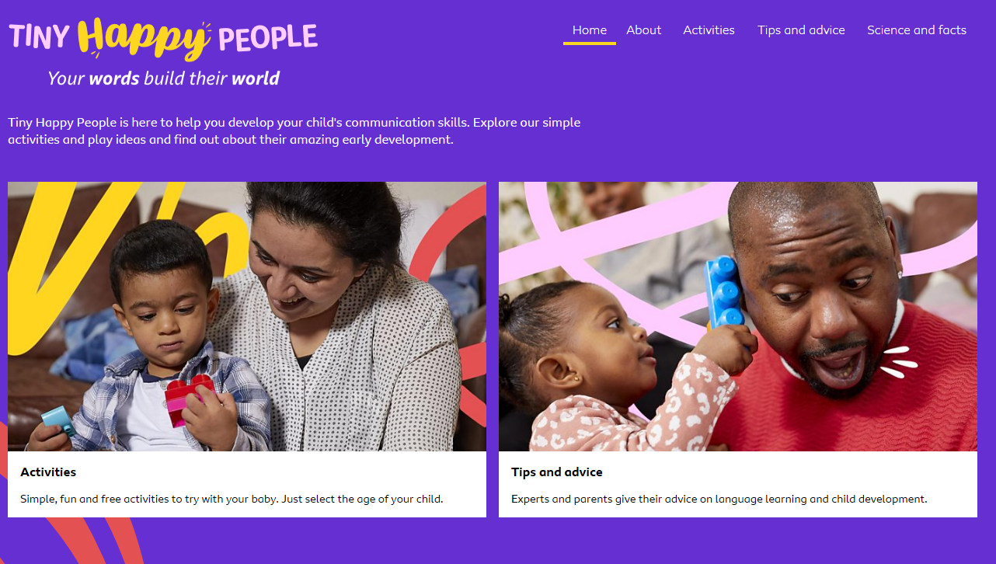

Games are a great way of developing the foundation skills for communication, reading and writing, as well as lots of other aspects of the Early Years curriculum. Dr Michelle Peter shows us three games that are loads of fun for the whole family, full of learning opportunities and easy to play.https://www.bbc.co.uk/tiny-happy-people/THP-at-home-playing-games-4-5-years/zm9q96f

Here to support you
If you’d like more ideas or advice to support reading for the child that you’re fostering, feel free to contact Sara Martin, Early Years and Primary Specialist at Sutton Virtual School on sara.martin@cognus.org.uk.

