Information, Tips & resources to promote writing
We are passionate about supporting every child in care to be a writer. We investigated the latest research and guidance about how to promote writing and put together this summary of key tips, which we adapted for you to try at home:
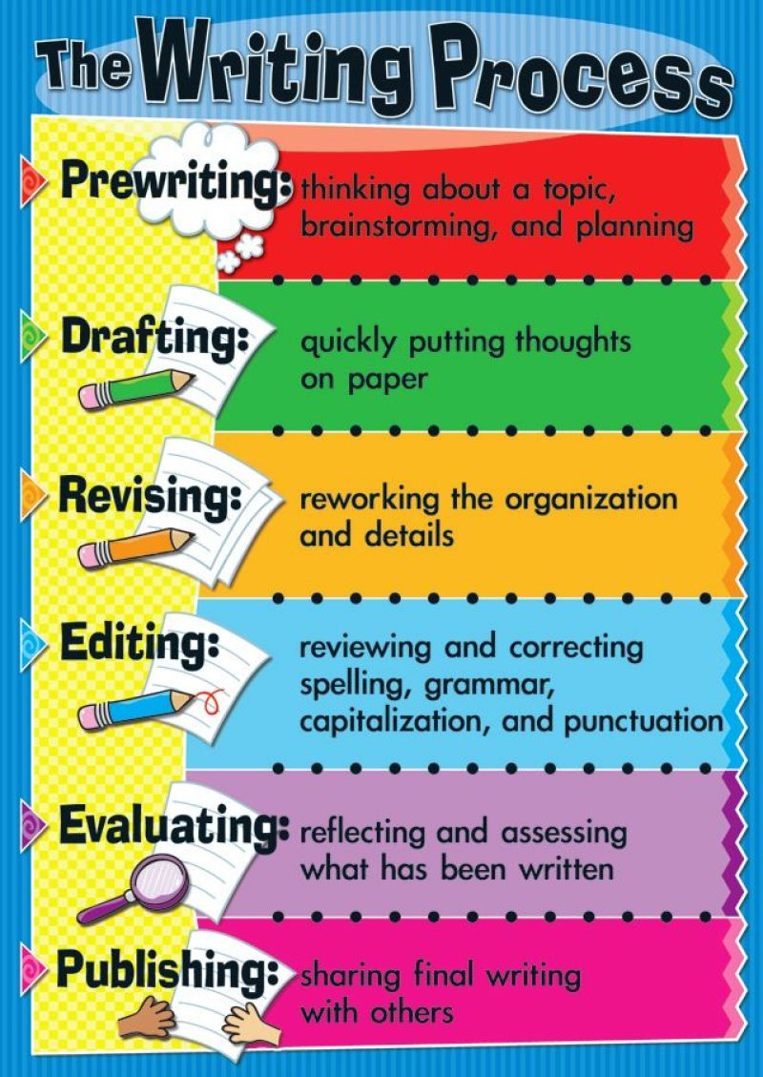
- Provide a range of meaningful opportunities to write for real purposes and audiences
- Model the processes of writing yourself, including letters you might type or email
- Immerse children in high quality texts, both visual and digital
- Look up professional authors and their processes with your children – there are lots of current, popular authors sharing their tips
- Give children time and space to develop their own writing ideas and support children to identify as writers and develop their own authentic voice
- Celebrate writing and invite children to present, share and celebrate their writing with your family, friends, school and by entering competitions
You can find more detailed information about this on the Centre of Literacy in Primary Education website, including more guidance about inspiring writing in each key stage.
Our top tip
“Children love receiving their own post! Send them a little letter and gift in the post! Share letters and cards from friends, family or formal letters from businesses. Discuss the layout and the purpose of the letter. Invite children to help you draft a reply or write to a pen pal or their own. Encourage older children to consider use of vocabulary and style to match their audience.”

Here for you
If you’d like more ideas or advice to support writing or readiness to write for the child that you’re fostering, feel free to contact Sara Martin, Early Years and Primary Specialist at Sutton Virtual School on sara.martin@cognus.org.uk.

