Ideas & Activities to promote reading for Primary school-aged children
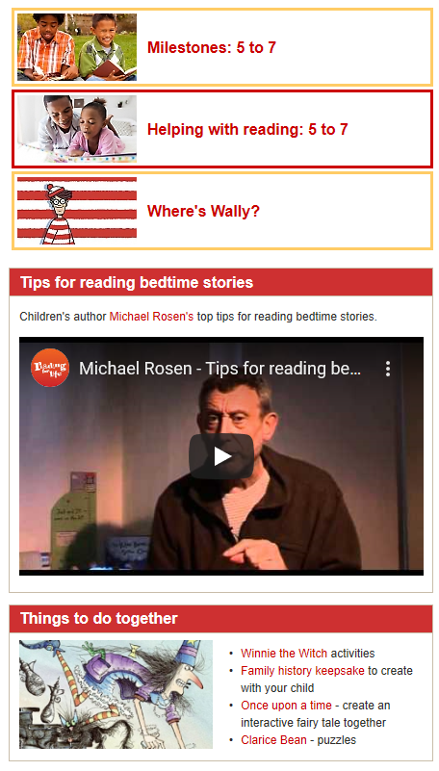
Inviting children to read to you as well as listening to you read to them is important, particularly for this age-phase, as they become more proficient readers.
The Words for Life website has video clips and activities that you could try at home.
Phonics
As children develop their independent reading skills, they will use their knowledge of phonics to segment and blend words together. Words for Life also has a Phonics section with video clips and phonic activities:
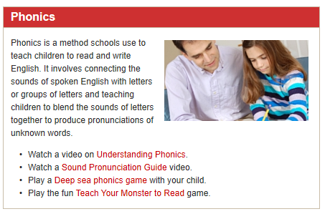

The BBC’s Alphablocks might be helpful in supporting younger children to learn their phonics. It has five colour-coded stages and is based on the ‘Letters and Sounds’ programme, so it will link well to their learning at school. There is also a guide for parents and carers.

Developing reading skills
As children become more proficient readers, they will be able to gain a better understanding of the text. You can help them to develop their comprehension skills by asking questions about the text. Reading VIPERS are prompts based on the National Curriculum and promote reading comprehension skills.
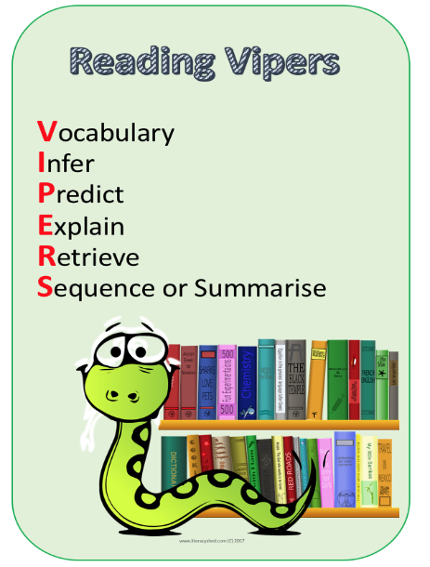
Click here for KS1 and KS2 VIPERS that you can print out to use alongside reading at home.

Click here for short inference ‘challenge’ cards.

Developing a love for reading
We want every child to be a reader and to enjoy reading for pleasure. Reading can be relaxing and open up real and imaginary worlds for the imagination to explore.
Here are some ideas to promote a love of reading at home:

Make a reading nook: is there somewhere cosy for children to read at home? Add fairy lights, cushions, posters and easy access to their favourite books.
Write a book review: invite your child to write a review, or even make a collection of reviews into a book!

Click here for a book review template
Click here for a book review template (more detailed)

Consider subscribing to a children’s magazine: there are lots of high-quality magazines for primary and older children. Favourites include the National Geographic for Kids, Aquila and The Week Junior, though there are plenty more.
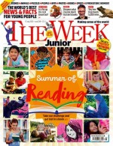
Here to support you
If you’d like more ideas or advice to support reading for the child that you’re fostering, feel free to contact Sara Martin, Early Years and Primary Specialist at Sutton Virtual School on sara.martin@cognus.org.uk.

