KS1 Reading VIPERS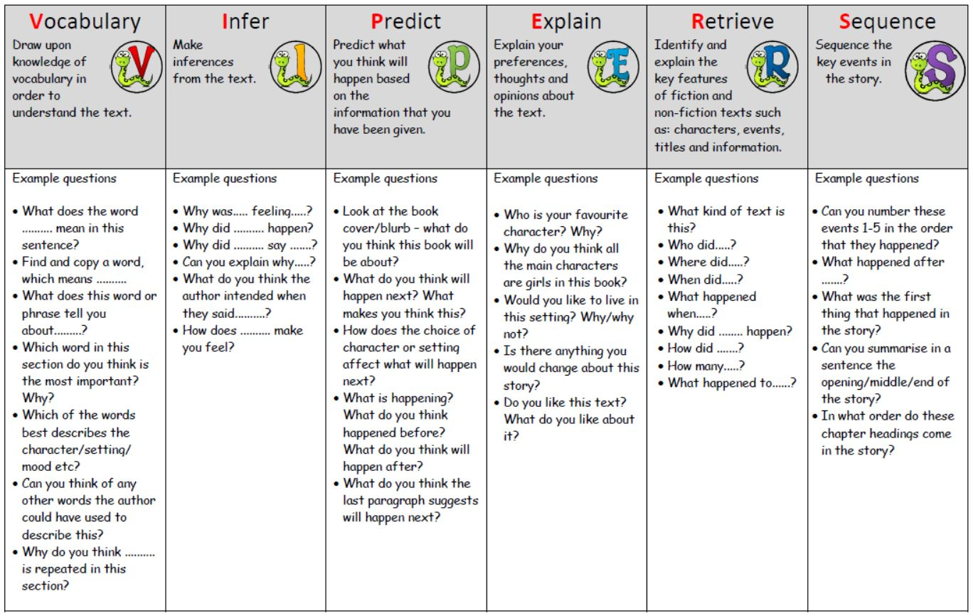

KS2 Reading VIPERS
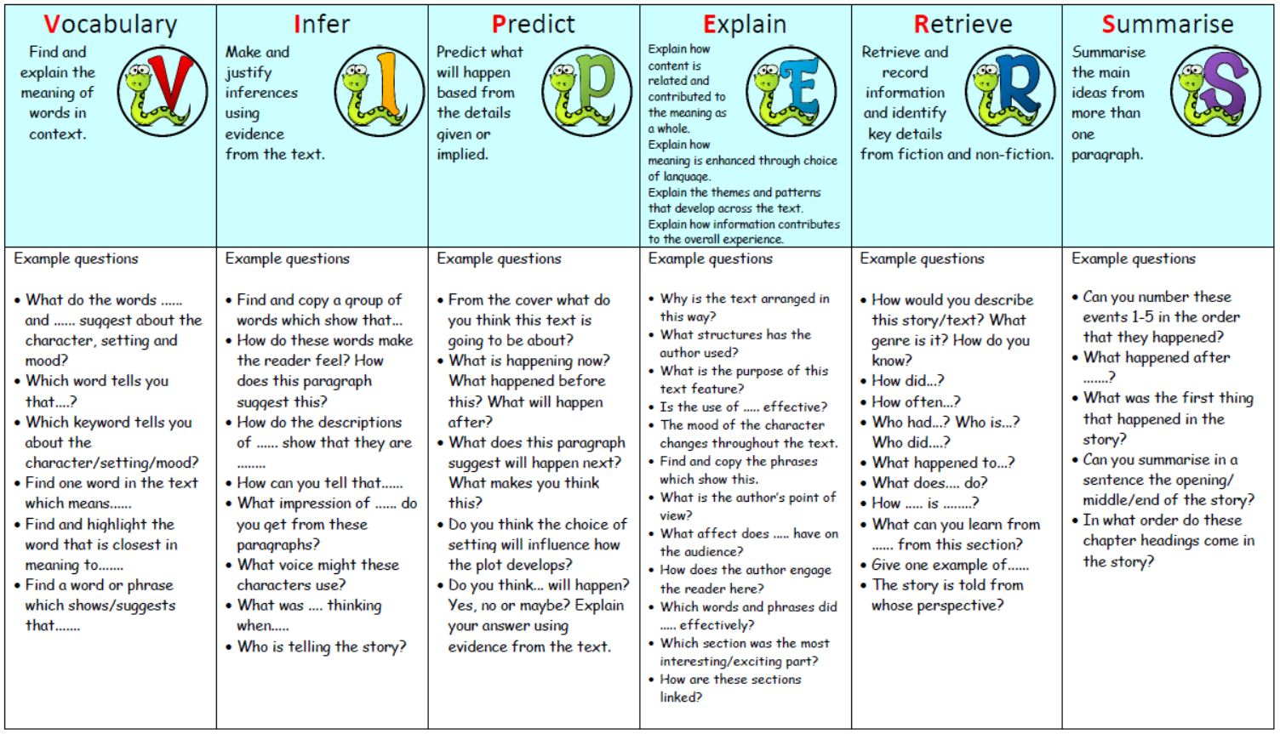
https://www.st-margaretsifield.w-sussex.sch.uk/page/?title=Reading&pid=1237

