Sutton Virtual School using CPD Website

Please read these instructions very carefully as they will help make your sign-up process and booking on to sessions a lot easier. This website was developed for schools so please ensure you follow all instructions below as some fields will not be relevant for yourself.

- Go to www.suttoncpd.cognus.org.uk and click register in the top right hand corner.
- For the registration process there will be some not relevant to yourself so please fill in as listed below:
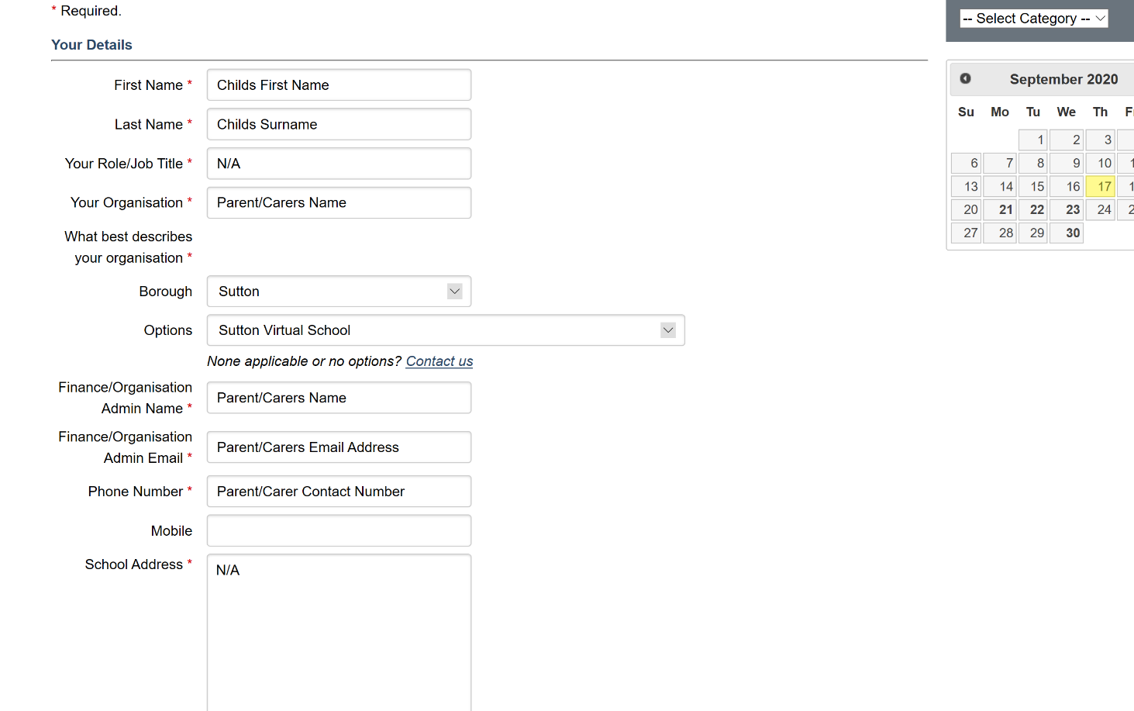

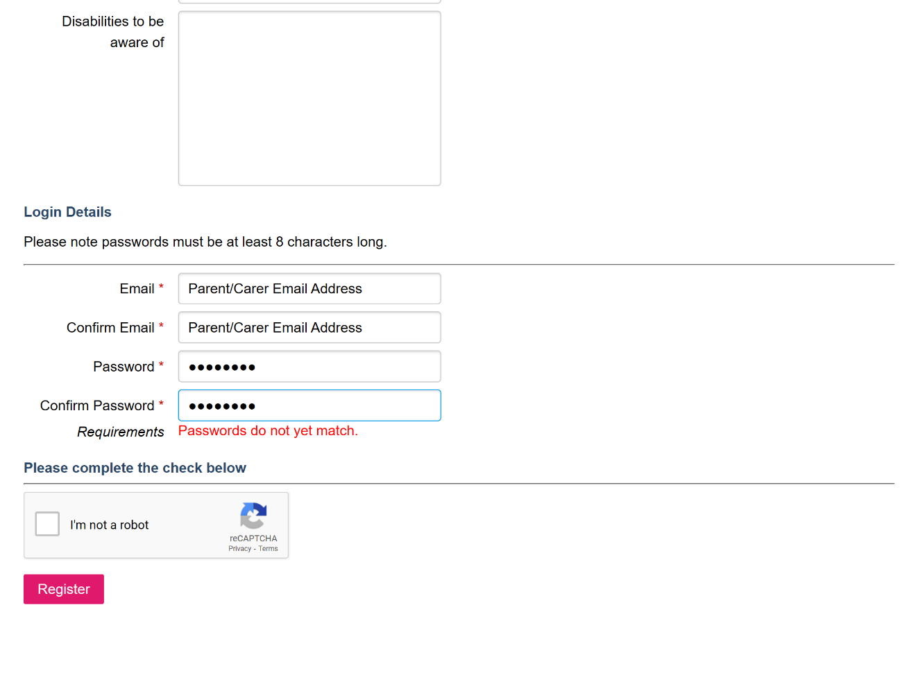

Just to recap, the fields you need to fill in and with what information:
First name – Childs first name
Last name – Childs last name
Job Role: N/A
Organisation: Parent/Carers Name
Borough: Sutton
Options: Sutton Virtual School
Finance Admin Name/Organisation: Parent/Carers Name
Finance Admin Name/Organisation Email: Parent/Carers Email Address
Phone Number: Parent/Carers Contact Number
School Address: N/A
Login details section:
Email: Parent/Carers Email Address
Confirm Email address: Parent/Carers Email Address
Password – your choice
Confirm password – repeat your choice of password

Now you’ve created an account, you will be able to book on to the Sutton Virtual School Events.
Please note all courses are listed in date order
Please scroll down to the date of the activity where you will see the events listed or
- Select by category > --Sutton Virtual School to see our current events
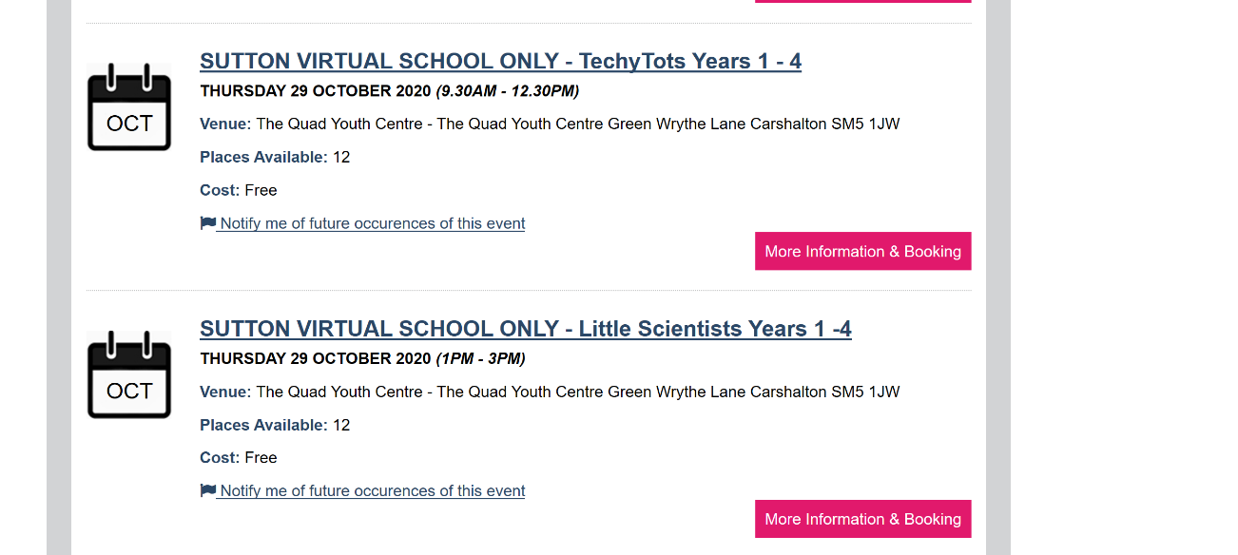
Please click on ‘More Information and Booking’ and then accept to the Terms and Conditions and select ‘Book now’ you will be added on to the course and will receive a confirmation email as well as a reminder email a few days before.

