Fine Motor Skills
What are Fine Motor Skills?
The ability to perform small, precise hand movements with fluency and accuracy. It includes picking up a variety of different items with varying grips and grasps.
Why do we need them?
It facilitates the development of mature functional hand grasps, fine hand movements, manipulation and dexterity which enable us to complete everyday activities such as play, handwriting, cutting, dressing, eating with cutlery etc.
Activities to help:
Hand strength: | - Theraputty or playdough play / exercises  - Water play with spray bottles, squeezing sponges  - Pipette  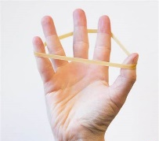  - Paper tearing and scrumpling  - Cutting cardboard  - Stress balls  - Tug of war  - Theraband  - Using tweezers and tongs  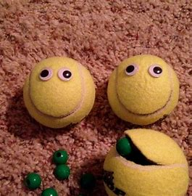  - Washing Pegs  - Punching holes with a punch  - Tennis ball packman game  - Finger bowling or football  - Finger star jumps with elastics  - Origami  - Popping bubble wrap
Dexterity: | - Finger puppets and action songs  - Stickers and stamps  - Posting games  - Elastic board designs  - Manipulating coins / picking up small items  - Squirrelling  - Card games  - Wind-up toys / spinning tops  - Nuts and bolts  - Hand and finger painting  - Finger twister  - Pegboards  - Board games e.g. Snakes and ladders, Tumbling monkey  - Tricky fingers game
Bilateral integration | - Building block towers  - Lego  - Threading  - Opening and closing jars  - Cooking  - Cutting  - Dressing tasks e.g. buttons, zips etc.  - Eating with cutlery  - Musical instruments e.g. drumming, tapping sticks
Handwriting: | - Tracing / stencils  - Pre-writing shapes  - Writing in a variety of textiles  - Using short crayons / chalk to improve grip  - Writing on vertical surfaces e.g., paper on wall, white board.  - Midline crossing-e.g. drawing rainbows&pre-writing patterns  - Fluency patterns e.g. lazy 8’s, spirals, zigzags.
Useful websites:
- https://www.theottoolbox.com/
- https://www.nhsggc.org.uk/kids/resources/ot-activityinformation-sheets/theraputty-hand-strength-exercises/#:~:text=Follow these tips for the best posture when,the chair, sit up tall with back straight
- https://otplan.com/activity/feed-the-ball/
- https://www.childcareland.com/free.html
- https://www.ot-mom-learning-activities.com/fine-motor-activities.html
- https://www.iow.nhs.uk/our-services/community-services/occupational-therapy/Paediatric%20occupational-therapy/Handwriting%20and%20Fine%20motor%20skills
- https://theinspiredtreehouse.com/hand-strengthening-exercises-and-activities/
Useful Apps – but just remember, nothing beats the real thing:
- Wet-Dry-Try Handwriting‬ ‬‬‬‬‬‬‬
- Writing Wizard
- LetterSchool ABC Phonics and handwriting for kids

ADDENDUM:

Terminology you may encounter when exploring fine motor skills and activities:
- Dexterity: skill in performing tasks, especially with the hands.
- Manipulation: the action of manipulating something in a skilful manner.
- Bilateral co-ordination: the ability to coordinate both sides of the body at the same time in a controlled and organized manner; for example, stabilizing paper with one hand while writing/ cutting with the other.
- Finger isolation: the ability to move one finger at a time. Separating the movements of one finger from the movement of the other fingers is a tricky, but important fine motor skill for kids.
- Thumb opposition: refers to the ability to turn and rotate the thumb so that it can touch each fingertip of the same hand.
- Midline crossing: the ability to reach across the middle of the body with the arms and legs crossing over to the opposite side. Examples include being able to draw a horizontal line across a page without having to switch hands in the middle or sitting cross-legged on the floor.

Grasp development on typical development children:
10 months  Pincer grasp | 15-20 months Palmar supinate grasp | 2-3 years Digital pronate grasp. | 3-4 years quadruped grasp | 3-4 years static tripod grasp | 5-6 years dynamic tripod grasp
 | 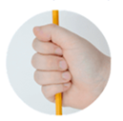 | 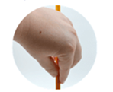

Pre-writing shapes:
Children should be able to form these 9 pre-writing shapes before asking them to write:
