SPEECH LANGUAGE & COMMUNICATION NEEDS SERVICE

TEACHER QUESTIONNAIRE FOR SPEECH (FORM B)
Please return to SENDCO (Attach to SLCNS referral form)
* Obligatory fields - MUST be completed for the referral to be accepted. Incomplete referrals will be returned.

*Child’s name:
*School:
*Teacher:
*Date: | *N/C Year:

*In order to show progress please complete this form using a RED pen and then use a GREEN pen at the end of the block of intervention*

If you feel any child in your class is struggling to say their speech sounds correctly, you can administer this quick test. If they have difficulty producing these words, please complete the FORM A and SLCNS REFERRAL FORM, for a member of the SLCNS to come and see this pupil.

- Point to the picture and ask the child to name it
  - If they say the sounds in the word correctly put a tick next to it
  - If they don’t say the word, ask them to repeat after you
  - If they say the word incorrectly, try to write down the word as it sounds
    - e.g. if they say “Star” as “Dar” record it in the box

Item No | Prompt | Pupil
1 |  | STar Dar  X

Target words are written in BOLD Capital Letters

Item | Prompt | Word | Item | Prompt | Word
1 | 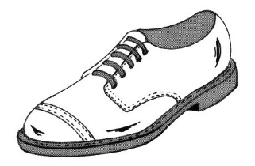 | SHoe  o | 12 |  | LioN  o o
2 | 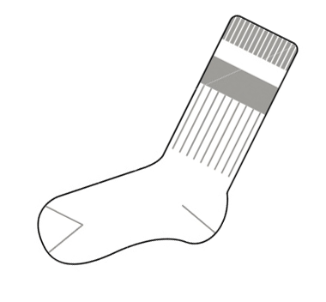 | SoCK  o o | 13 |  | SMile  o
3 | 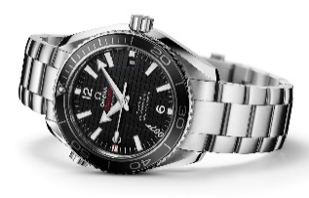 | WatCH  o o | 14 |  | Yoyo  o
4 |  | NoSE  o o | 15 | 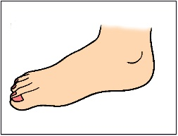 | FooT  o o
5 |  | MouTH  o o | 16 | 2 | Two  o
6 |  | Go  o | 17 |  | Cloud  o
7 |  | STop  o | 18 |  | STRiNG  o o
8 | Point to your hair | Hair  o | 19 |  | SLeeP  o o
9 |  | PenCil  o o | 20 |  | ReD  o o
10 | Point to the door | Door  o | 21 | You pull up the .... | ZiP  o o
11 | Point to your thumb | THuMb  o o | 22 | Point to your chair | CHair

Comment below:
Speed of speech (Too fast/too slow) 1 2 3 4 5
Tone of voice (Flat & monotone/High pitched) 1 2 3 4 5
Overall intelligibility (Highly unintelligible/intelligible) 1 2 3 4 5
Additional comments:

PLEASE RETURN THIS FORM TO THE SLCNS WITH THE REFERRAL FORM & FORM A

