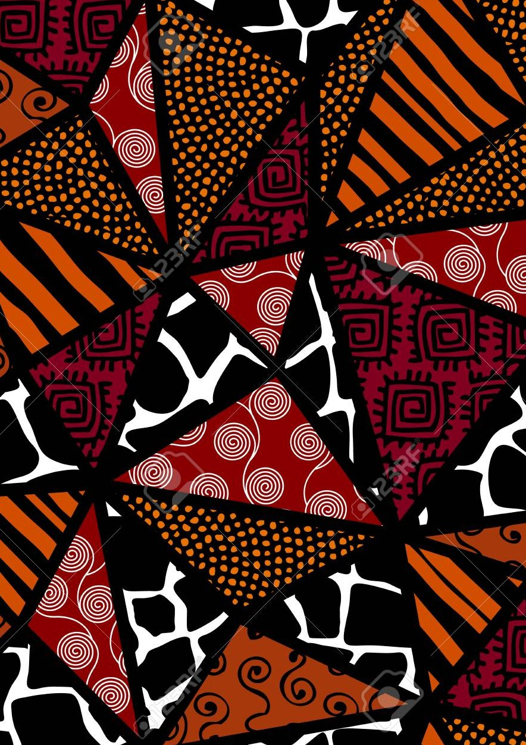
our history
our future

Black History month

What's  happening? | Details | Contact for more info
cooking session: food made with love  Caribbean and african cuisines | Date: 20th October  Time: 4.30pm-6pm Location: The quad Open to: everyone | name: Ben eckett  EMail: ben.eckett@s utton.gov.uk
Black History walking tour of London | Date: 26th October  Time:  TBC  Location: Central london Open to:  Care leavers (10 spaces) Lunch included | Name: Laura Toal  Email: laura.toal@ sutton.gov.uk
Film and chill Movie viewing:  A new legacy Space jam  Movie nights @the quad TBC | Date: 27th October  Time:  2pm Location:  Sutton Community Dance hall  Open to: Everyone Snacks provided | Name: Carolyn Ankrah  Email: carolyn.ankrah @cognus.org.uk

What's happening?

Details
Contact for more info

carnival

music,costumes & history
Date: 28th October
Time: 12pm-4pm Location: The Quad Open to: Everyone
Snacks provided

Name: paul arthur

Email: Paul.arthur@su tton.gov.uk

Successful black business owner Workshop

guest speaker: leon mann

Museum of London Docklands

Feeding Black: Community Power & Place exhibition
Date: 21th October
Time: TBC
Location: Virtual Open to: Everyone
Date: TBC
Time: TBC
Location: E14 4AL
Open to: Everyone
Name: Shakira Myers-
Grey

Email: shakira.myers- grey@sutton.gov. uk

Name: Shakira Myers-
Grey

Email: shakira.myers- grey@sutton.go v.uk

Hair workshops roots: treatments & management Black hisTORY: Tea & Talks black girl magic: pamper session
Lets celebrate!
Date:
TBC
Time:
TBC
Location:
Hair salon & The Quad Open to:
TBC

Name: nicole luckett

Email: nicole.luckett@su tton.gov.uk

