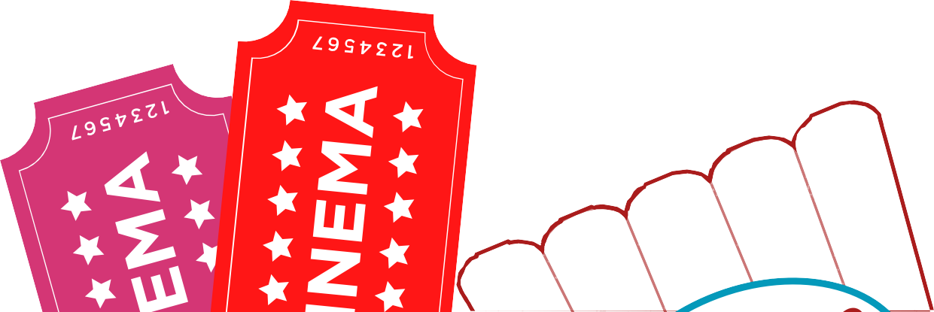For Black History Month
Film and Chill

CHILL

OCTOBER 27TH | 2 PM
SUTTON COMMUNITY DANCE, ST NICHOLAS CENTRE, ST NICHOLAS WAY, SUTTON SM1 1AX
POPCORN AND DRINKS PROVIDED
in partnership with

