Reading Together:
A carer’s guide to reading with 3-7 year olds

booktrust.org.uk

Sharing a book with your child can help their development, communication and creativity.

Plus, carers who took part in a recent research project said that reading together had made a positive difference to their relationship with their child.*
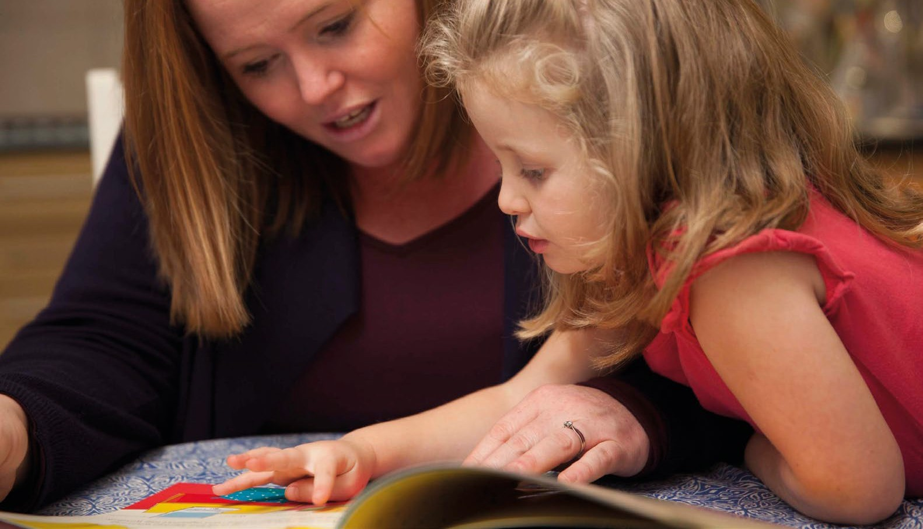

Being a good role model in reading is one of the best things you can actually do.
Foster carer

Reading for pleasure is about choosing to read for enjoyment and entertainment. It means you can read anything, in any format, as well as talking to
your child about books.

Research shows that reading for pleasure is more important for a child’s progress in school than their background or parental factors.*

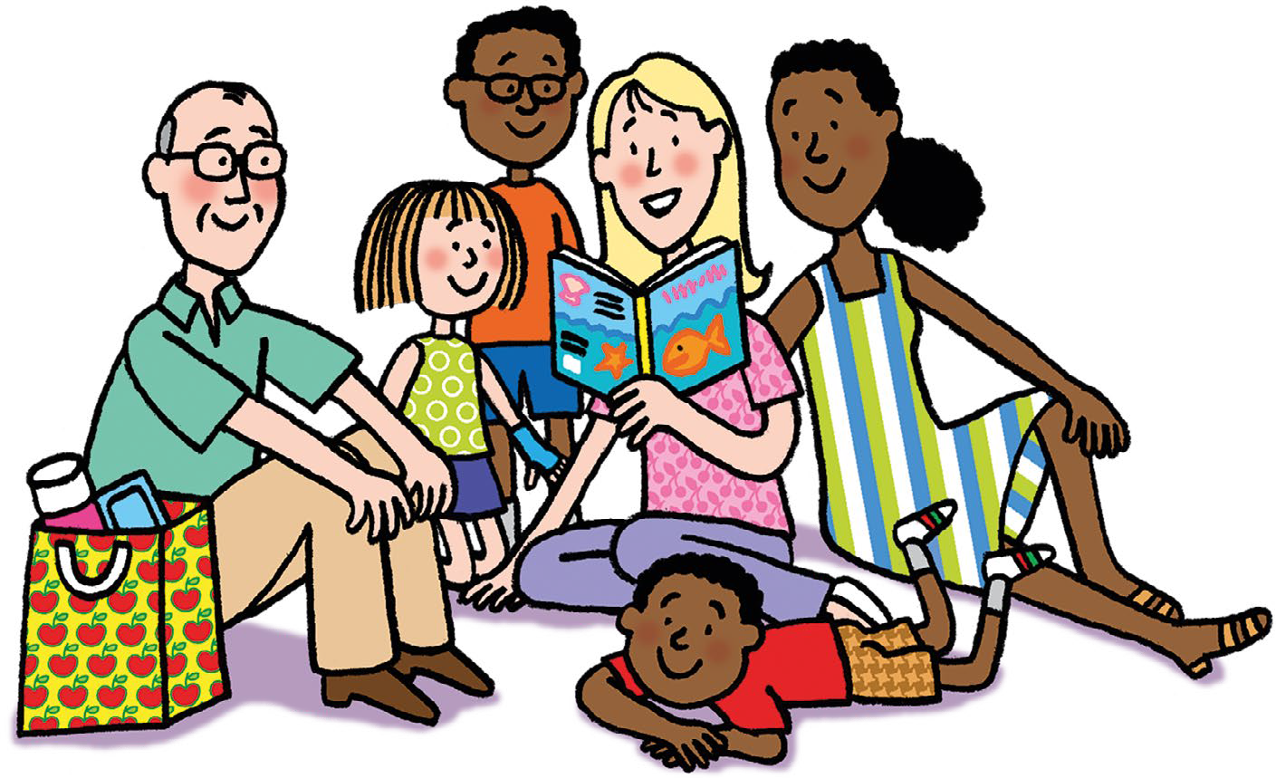

Illustration © Nick Sharratt

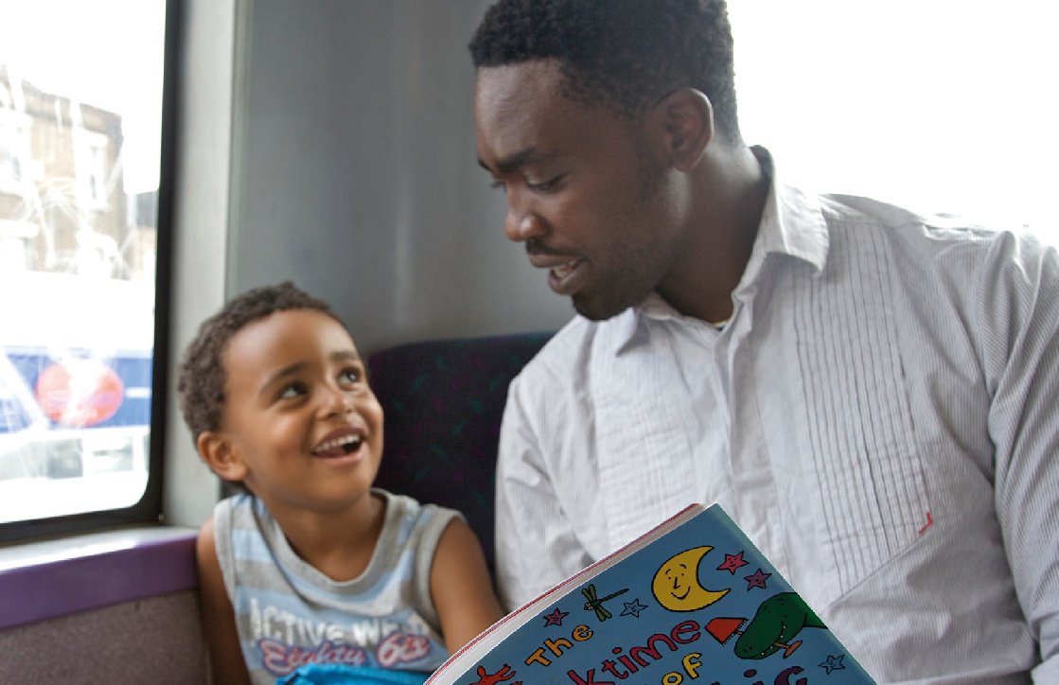
Making reading part of everyday life

It may feel like there’s not enough time in the day, but reading with your child doesn’t have to be time-consuming.

Spending just ten minutes a day reading with your child can make a real difference.

Why not...

- Encourage your child to carry a book to read during journeys, or even while waiting for an appointment.
- Help your child to read words on signs and posters when out and about, and talk to them about what they say.
- Read a recipe with your child whilst you are cooking.
- If you have several children in your household, why not encourage the older ones to read with the younger ones?

Illustration © Nick Sharratt

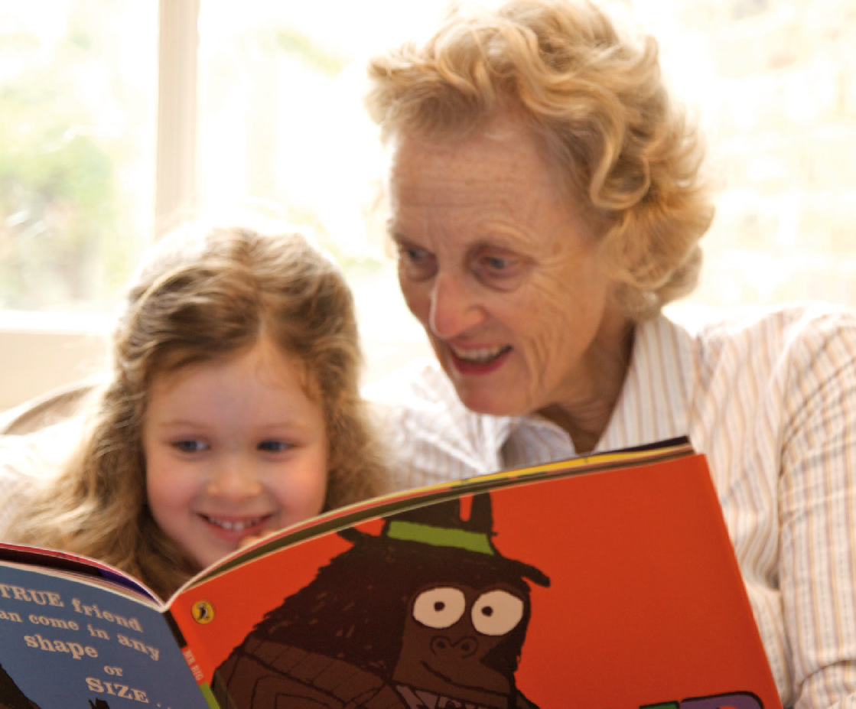

It did not matter if there was upset or behaviour issues which there was loads of...we could still do it [reading]... and it was nice to do that at the end of the day to show that we still cared about them no matter what had happened that day.
Foster carer

When reading with your child:

- Encourage them to choose a book they would like to read - they are more likely to enjoy a book they have chosen themselves. It could be a fact book instead of a story.
- Let them see your facial expressions and don’t be afraid to tell part of the story in a funny voice to make them giggle!
- Don’t worry if your child wants to read the same thing more than once, even if you think it might be too easy for them. Having a favourite book or story can help them understand that reading is fun.
- Remember to give your child time to think before answering questions.

Illustration © Nick Sharratt

For children aged 3-4, you might also want to:

- Encourage them to hold the book and turn the pages themselves.
- Ask questions about the book you’re reading together, starting with simple choices like, ‘Are they happy or sad?’
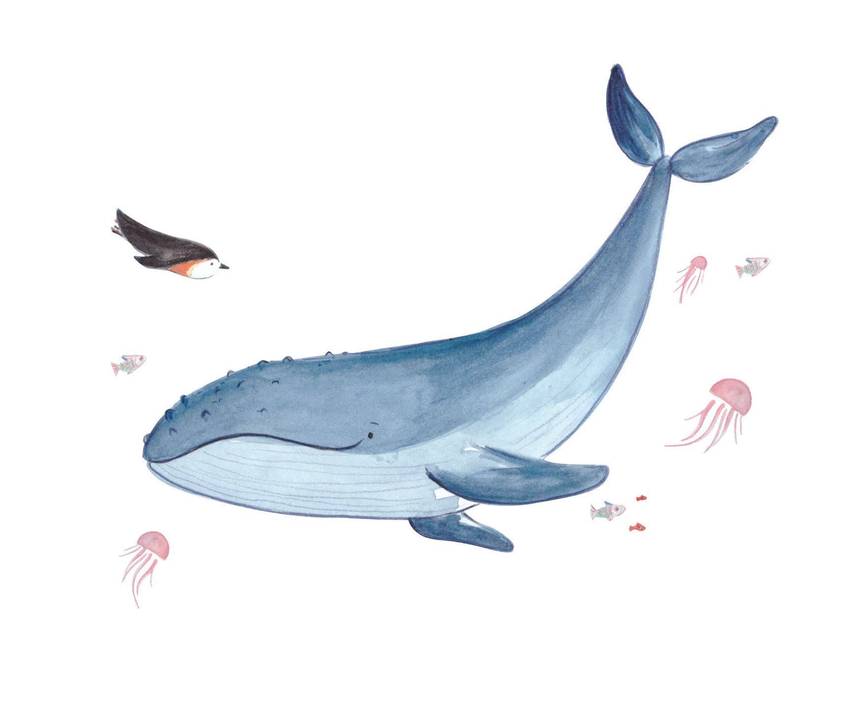
- Make it interactive by giving simple instructions like ‘Can you fnd the whale?‘ and getting them to point to pictures on the page.

Illustration © Fiona Lumbers

For children aged 4-5 (or more confdent 3 year-olds):

- Try to use questions that encourage more than a yes or no answer. For example, ‘Where do you think the penguin is swimming to?’
- Encourage your child to talk about the people and places in stories.

For children aged 5-7 (or more confdent 4 year-olds):

- Support them to do activities related to reading, like drawing their own book cover or their favourite character.
- Encourage your child to ask you if there’s a word they don’t understand. You could look it up together.
- Ask open questions like ‘What do you think will happen next?’

Getting your child reading is not always easy, and you may need to try a few different things to help them.

What you can do if...

Your child fnds it hard to concentrate
Reading together doesn’t have to mean sitting
down and reading a book in one go. You could start by reading a few pages and go back to it later. You may need to remind your child what happened before.

You don’t have time
Remember, just ten minutes a day can make a huge difference. If you can’t read every day at frst, try reading 3 days a week and build it up from there.

Illustration © Jim Smith

Your child has a negative view of reading
You can help to reassure your child by focusing on the enjoyment of the book. You could also start by reading to them and getting them to listen and join in.
Finding short books about topics your child is interested in can also help get them reading.

You don’t feel confdent reading aloud
Try to remember that for your child, reading with you is also about spending time together. If possible, try to sit close together and hold the book between you to show that you’re both interested.

Illustration © Nick Sharratt

Where to fnd out more:
Find books for a range of ages, and on a range of topics by using BookTrust’s book fnder: booktrust.org.uk/books/bookfnder
Take a look at BookTrust’s themed booklists to help you fnd your child’s next book:
booktrust.org.uk/books/booklists
You could visit your local library to fnd even more books for your child.

@booktrust G8 Battersea Studios
80 Silverthorne Road Battersea
London SW8 3HE

About BookTrust
BookTrust is the UK’s largest children’s reading charity.
For more information about reading with your child, visit:
booktrust.org.uk

* The information in this booklet is informed by a range of research, as well as wider evidence and evaluation. All references can be found at booktrust.org.uk/tips-for-carers-and-foster-families

