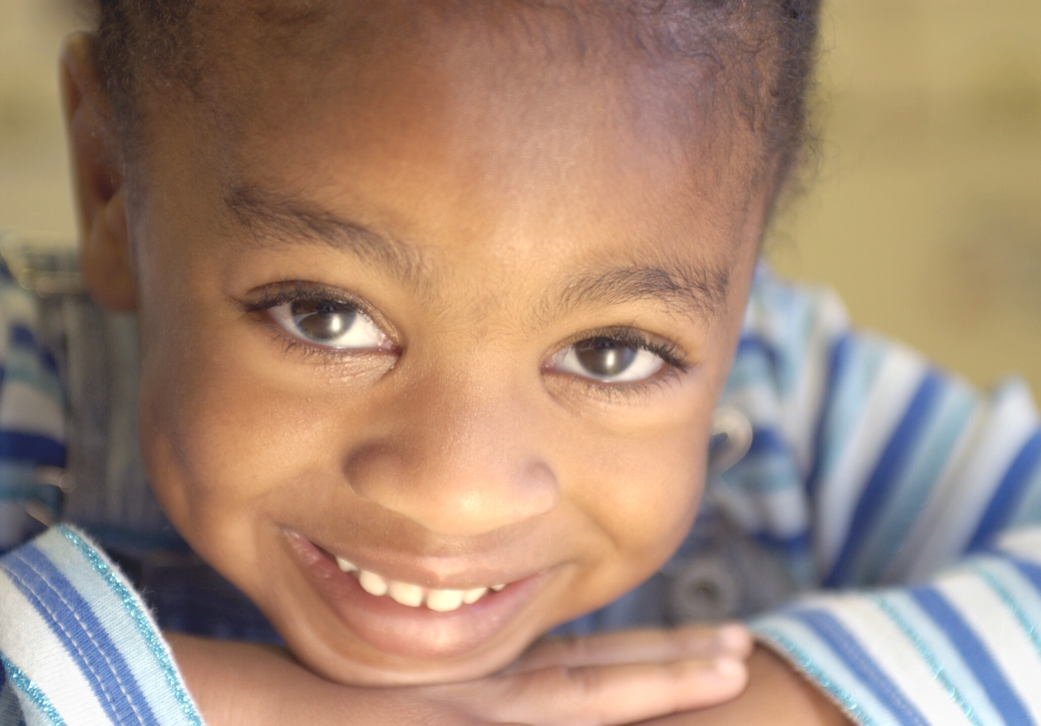

TRAUMA & ATTACHMENT

UNIVERSAL SUPPORT
OPEN NOW AND BOOKING FOR THE YEAR AHEAD!

Tailored Trauma and Attachment Training

Development of Attachment
Impact of Trauma on Brain Development and Learning Behavioral Indicators of Trauma
Trauma Informed Strategies

Development of a Trauma and Attachment Champion in Each School

Ongoing Trauma and Attachment Training Bespoke Sessions and Mentorship

FOR BOOKINGS AND FURTHER INFO PLEASE CONTACT

SASHA-GAY BROWN
SASHA-GAY.BROWN@COGNUS.ORG.UK TELEPHONE: 07534525707

