Sutton Virtual School
Previously Looked-After Children: A booklet for families and young people
Visit our website
Follow us on Twitter @SuttonVS_CLA

COntents
- Previously Looked-After Children – an introduction
- Adoption
- Pupil Premium funding and eligibility
- Special Guardianship / Supervision Orders
- Care Leavers
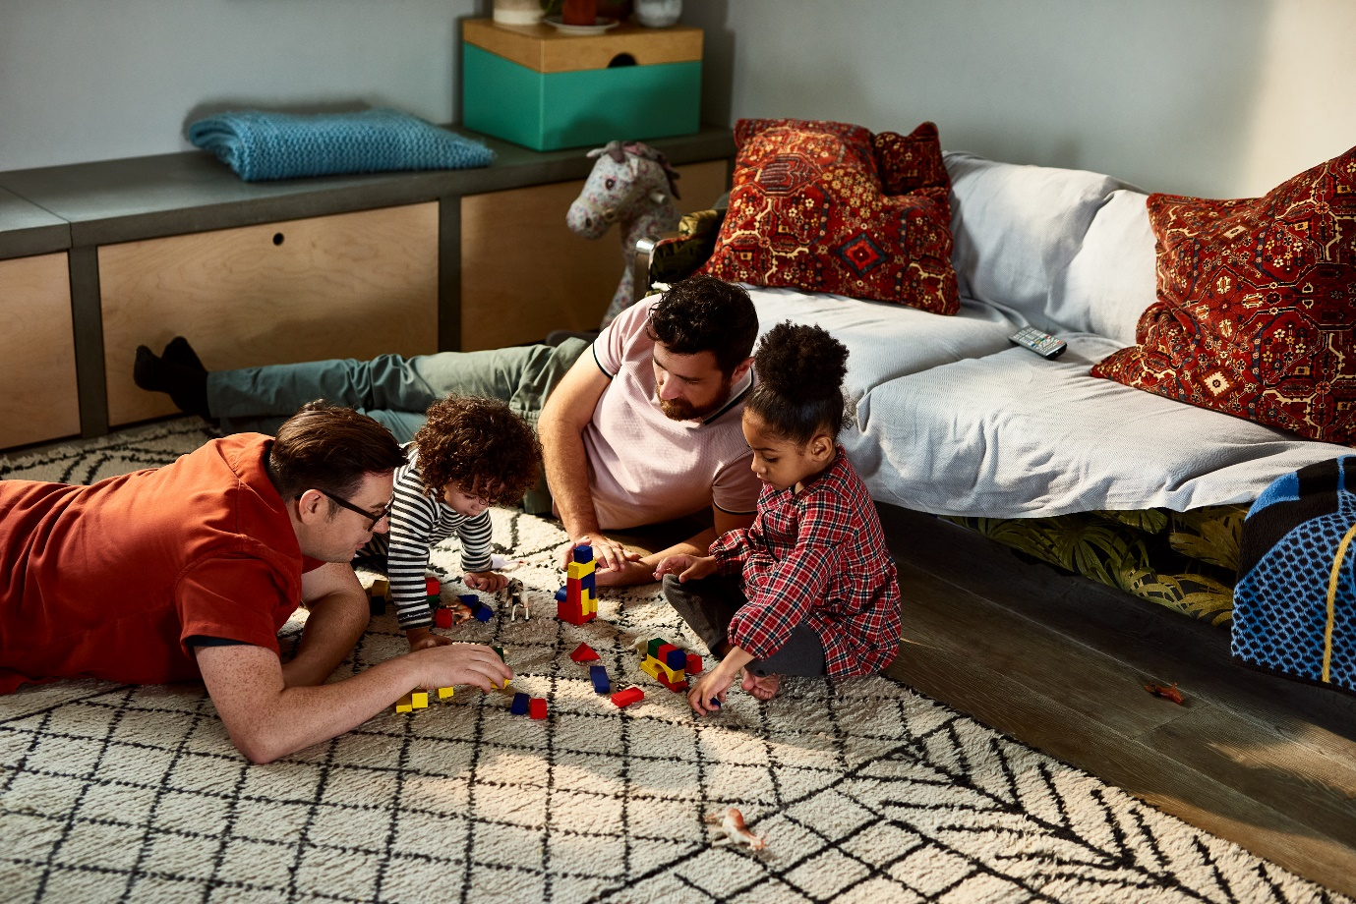

Previously Looked-After Children

‘Previously looked-after children’ are those who have now come out of care. This could be through a range of arrangements, including through adoption, a Special Guardianship Order, a Supervision Order or through adulthood.

At the London Borough of Sutton, we want all previously looked-after children and young people have support that they need to fulfil their potential.

This booklet provides a guide to the support available to young people in Sutton who were previously in care, and signposts how to access it.

Adoption
When a child is adopted, they will no longer be ‘looked-after’ but as a previously looked-after child, there is other support you can access. If you are adopting a child, you can request funding through the Adoption Support Fund.

Adopt London South (ALS) is a Regional Adoption Agency partnership of 9 local authorities – Croydon, Kingston, Richmond, Lambeth, Lewisham, Merton, Southwark, Sutton and Wandsworth. Their specialist adoption staff find families for children, recruit adopters and offer post adoption support to children, families, birth parents and adopted adults.

You can find lots of information about post-adoption support on their website at: https://adoptlondon.org.uk/adoption-support/

If you’re looking for peer support from other adopters, these links take you to some useful organisations:
- https://wearefamilyadoption.org.uk/
- https://www.first4adoption.org.uk/adoption-support/
- https://www.adoptionuk.org/support
- https://newfamilysocial.org.uk/- for LGBT adoptive families

There is a useful adoption guide for grandparents
http://www.innerworldwork.co.uk/wp-content/uploads/2017/04/An-Adoption-Guide-for-Grandparents.pdf

The National Association of Therapeutic Parents (NATP) offers a range of support group services, peer support online, a members hotline for 1-2-1 consultation, listening circles, plus training and advice to families. You can contact them on 01453 519000 to discuss membership and its benefits.

Special Guardianship/ Supervision Orders

Sometimes, the Court will grant the Local Authority a Supervision order when a child is returned to their parents. In this case, the local authority will still be involved in providing the child assistance and support. Where children are on a Child in Need or Child Protection plan, the Virtual School will continue to promote the education of this group of children, though the Government has set these duties out to provide this through strategic work, rather than providing individual children and families support.

If a Special Guardianship Order is granted, any arrangements or particular support needs will be considered before the SGO is finalised and progressed. After an SGO has been granted by the court, Sutton has a post SG service, which can offer additional support, including:
- advice and counselling
- help dealing with other organisations such as schools and healthcare
- accessing therapeutic services
- training and support groups

Please liaise with your social worker for more information.

Pupil premium funds for Previously Looked-After Children
When a child is adopted, adoptive parents can apply for the school to receive pupil premium funds for the duration of their schooling. We encourage families to do this, so that the school has these important funds. Pupil premium funds can also be claimed for pupils who left local authority care on a special guardianship order (SGO) or child arrangements order.
Unlike pupil premium funds for children who are in care, it is the schools and not the Virtual School who are responsible for ensuring that pupil premium for previously looked-after children is spent within the Government conditions of the grant and importantly, this funding is not ring-fenced for the specific individual use of that child.
The purpose of pupil premium for previously looked-after children is to raise educational attainment and close the gap between them and their peers. It can be spent as the school see fit, and include spending on non-academic outcomes or activities that will also benefit non-eligible pupils.
If you have a query or concern about your child’s learning and development, or the use of these funds, we suggest contacting the school’s Designated Teacher or Inclusion lead to discuss this.

Care Leavers
Sutton has a Local Offer website for Care Leavers. Here you will find information about the support that is available to young people who have been in the care of the London Borough of Sutton and are now aged 16-25. The website explains your entitlements as a care leaver and can be found at: https://www.suttonlocalofferforcareleavers.org.uk/index.php
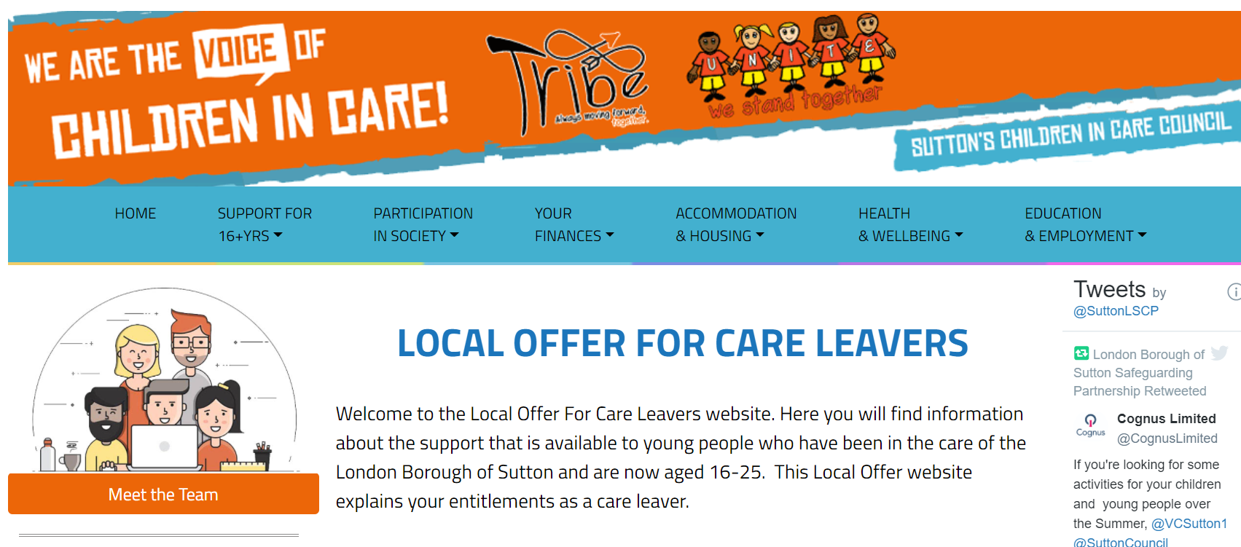The Leaving Care team can offer support with a range of issues, including:
- Education and Employment
- Accommodation and Housing
- Your finances
- Health and Wellbeing
The team can be contacted on 020 770 6600 or lcta@sutton.gov.uk .

