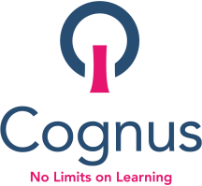
Dear all,

Welcome to our Summer/Autumn Update! We hope that you’ve enjoyed the summer and we now look forward to continuing our work with you in the academic year 2022-23.

Summary of Cognus Therapies’ work this year
- We have continued to work in partnership with NHS and Sutton colleagues to use feedback received from parents and young people to further develop the experience families gain from the local therapy offer
- We have been working with Sutton Parent Forum, Sutton Council, and SENDCos in schools to ensure communication about our services improves for everyone
- The Cognus Therapies team are using social media, podcasts and partnering with national agencies to deliver key messages in the most effective ways
- The team continues to follow national best practice guidelines to develop the therapy service
- Welcome packs were developed for families new to therapies services, please click here

Below, we have captured some specific examples of great work and impact that our team has delivered this year to improve outcomes for opportunities for children and young people.

Successes this year
- Thirty one of our primary schools took part in the iCAN Boost’ language intervention programme – ICAN are a children’s communication charity. The intervention was aimed at children with delayed language, but who wouldn’t typically meet the criteria for more specialist support. The aim was to narrow the gap between children with delayed language and their peers. Feedback from the schools has been very positive and many have expressed an interest in further training. We have been approached by iCAN about a pilot scheme for secondary schools and will keep you up-to-date with any further details and information when we receive it.
- Over the past year we have continued to capture data from termly therapy target reviews which form the basis of the small steps towards children/young people’s wider EHCP outcomes. To date, on average 95% of children/young people have demonstrated progress with these each term.
- In addition to targets and EHCP outcomes, we are working with the Royal College of Speech and Language Therapists to capture SaLT and OT outcome data using their standardised tool: The Therapy Outcome Measure (TOMS). This year, on average 85% of children demonstrated progress on the TOMS scales relating to impairment, activity, participation, and well-being.
- We are very proud of our ongoing work with the Downs syndrome project – led by Emily Harnett, Highly Specialist Speech and Language Therapist working with the local Get On Downs group and with Jo Cassey our Managing Director. Our Down Syndrome pathway has now been launched and we have been approached by another local authority about how Cognus Therapies can support them.
- Emma Perridge and Ashlea Stephens POST 16 Lead OT and SaLT have continued to develop our relationship with the Epsom Surrey Super 1’s, The Lord Taverners Cricket Team and have also been working with the Change Foundation a Sutton based award-winning charity that uses sport to change the lives of marginalised young people.
- Our dedicated therapists have continued to deliver therapy during the summer holidays to ensure that all children have received their statutory entitlement and have also been completing assessments too.
- We have continued to develop our strong relationships with universities so we can attract and then grow our own highly-skilled workforce for the future.

Resources and support for schools and families
During the Summer holidays, we have put together a small team of OTs and SaLTs who are continuing to develop our Graduated Response Toolkit which provides advice, guidance and therapy resources which are available on our website. We want to make it more accessible, user friendly and empowering for families and education setting with a focus on supporting our children and young people to develop independence with everyday tasks. We are also developing some training videos as part of these and look forward to sharing our revamped website and resources with you in the autumn term.
The previous version can be accessed here but do keep eyes peeled for our new look website!
Graduated Response for education based therapeutic support – Cognus

Twitter Account
We have a Twitter account that is regularly updated with news from the Therapy Team. Please follow us at
@cognustherapies

Podcasts
One of our recent podcasts (as part of Cognus’ Education Untapped series) features two of our therapists Ashlea Stephens, SaLT and Emma Perridge OT who spoke to Dan Levey from the Change Foundation about bringing young people together through and beyond sport. The episode highlights the work that Dan and the team do and aims to showcase and celebrate the capabilities and talents of young people that may have specific educational or therapy needs.

Take a listen here: Bringing young people together through and beyond sport

You can listen to all our podcasts here Podcasts – Cognus
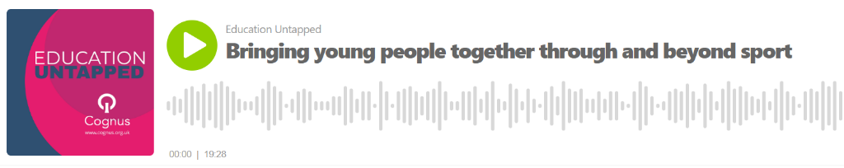

Should you have any questions relating to the services Cognus are providing, please do not hesitate to get in contact with the therapies team.

A list of key team members can be found here:
Patsy Winkley – Team Manager
Julie Kiely – Assistant Team Manager Alex Benjamin – Principal OT
Alison Rees – Highly Specialist SaLT – Early Years and ASD
Amber Burnett- Highly Specialist OT- mainstream and specialist primary and secondary
Ashlea Stephens – Highly Specialist SaLT – POST 16
Emily Harnett - Highly Specialist SaLT – Down Syndrome
Emma Perridge - Highly Specialist OT – POST 16
Helen Gardner - Highly Specialist OT – ASD and MLD Helen Raby - Highly Specialist SaLT – DLD
Jessica Brown - Highly Specialist OT – Mainstream
Jo Wells - Highly Specialist SaLT – Mainstream and Verbal Dyspraxia
Lisa Ogden - Highly Specialist SaLT – SEMH, Young Offenders and Trauma Rachel Wilson-Dickson - Highly Specialist SaLT – SEMH
Rose Fletcher - Highly Specialist SaLT – ASD
Shelly Fredericks – Highly Specialist OT - ASD
Tamara Rainsley - Highly Specialist SaLT – HI specialist
Tessa O’Brien - Highly Specialist SaLT – AAC specialist

Please contact your therapist directly via name.surname@cognus.org.uk or email the team inbox at
cognustherapies@cognus.org.uk and your query/feedback will be forwarded to the appropriate member of staff.

Thank you as always to our school partners and families that support our work to improve outcomes for children and young people. We look forward to a successful year ahead!

Kind regards,
The Cognus Therapies Team

