Online Safety Update
I am sure you will be aware of how much your children rely on modern communication technology such as the Internet, smartphones, and social networking as part of their daily lives, especially during periods of lockdown, school holidays and remote learning.
Technology moves very fast, and it is difficult to keep up with what your children are using or to even understand it. Children love playing games on the Internet, but do you know who they are playing those games with? What are they watching on YouTube? What are they posting online? What they are posting online today could affect their future chances!!
Age restrictions for social media –
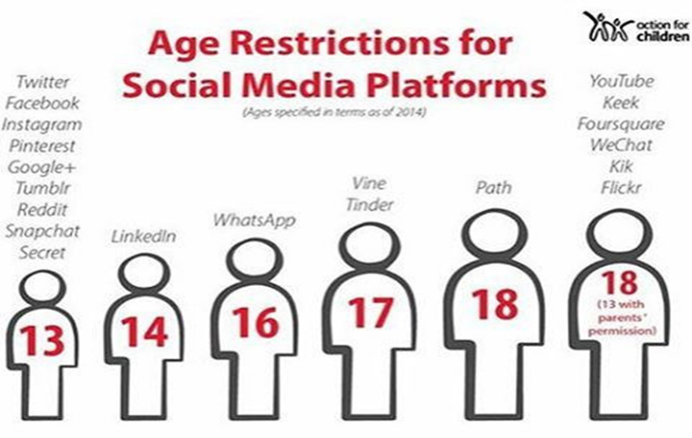
If your child likes watching You Tube but you do not like the content or you believe they are spending too long on screen, then download the free “You Tube for Kids App.”
- Easy to set parental controls.
- Limit which videos children can watch
- Set a time limit
- Switch off the search function
- Set an age-appropriate filter
Does your child love gaming? Do you know what games are suitable for the age of your child? Do you know if your child is playing “multi player games” where they can have conversations with strangers who are also playing the same game at the same time! (The average age of an on-line gamer is 38 years old!!!). askaboutgames.com is a useful website to find out if the game your child is playing or wants to play is appropriate for their age. Just put the name of the game into the search bar and it will tell you all about the game and any age restrictions.

