Understanding Risks Outside of the Home

What is Contextual Safeguarding?

Contextual Safeguarding is an approach to understanding, and responding to, young people’s experiences of significant harm beyond their families. It recognises that the different relationships that young people form in their neighbourhoods, schools and online can feature violence and abuse.
In a contextual approach to safeguarding, parents are involved as partners in safeguarding children outside of the home, including online, and are supported to understand and recognise indicators of extra-familial harm. Safety planning in responses to extra-familial risk should be informed by the needs of the whole family and not just focused on the individual child.

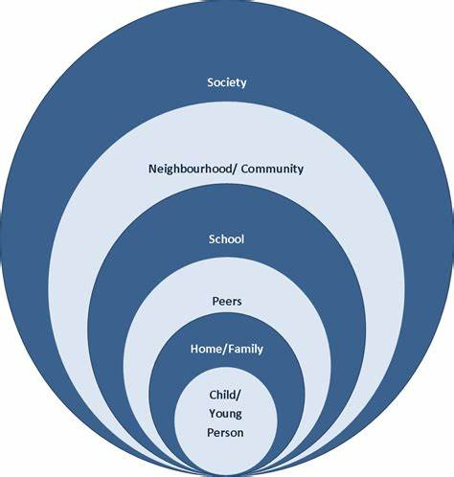

Please watch the two videos below to find out more:
Contextual Safeguarding: Re-writing the rules of child protection | Carlene Firmin | TEDxTottenham - YouTube

What is contextual safeguarding? - YouTube

If you have any concerns about risks outside of the home, please contact the police for further support.

