Books and resources to support trauma, attachment & anxiety
for children & young people

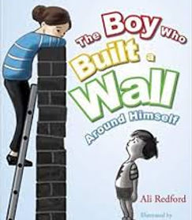

The Boy Who Built a Wall Around Himself

by Ali Redford

​

Written for children aged 4 to 9, this gentle full-colour picture book uses a simple metaphor to explain how children who have had painful or traumatic experiences can build barriers between themselves and other people. It will help children explore their feelings and encourage communication.
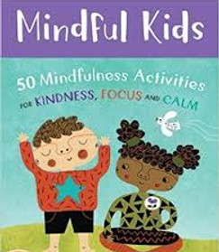

Mindful Kids

by Whitney Stewart

​

A boxed card deck with 50 creative mindfulness games, visualisations and exercises to help children feel grounded, find calm, improve focus, practice loving-kindness and relax.

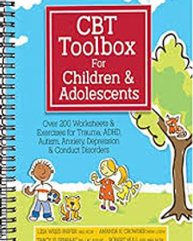

CBT Toolbox for Children and Adolescents

by Lisa Phifer

​

Provides resources based on CBT to help young people manage challenges they may face in life.

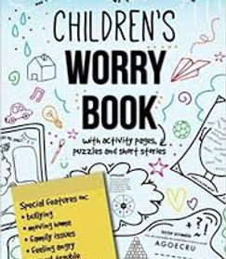

Children's Worry Book

by Children's Mindfulness

​

A journal aimed for those aged 6-12 which uses stories, exercises and mind clouds to document and manage thoughts and feelings.

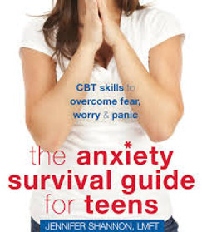

The Anxiety Survival Guide for Teens

by Jennifer Shannon

​

This book will teach you practical strategies for handling even the toughest situations that previously caused you to feel anxious or worried.

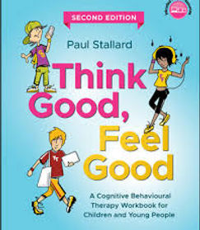

Think Good, Feel Good

by Paul Stallord

​

A CBT workbook for young people to help cope with low mood and anxiety. It starts by introducing readers to the origin, basic theory, and rationale behind CBT and explains how the workbook should be used. Chapters cover elements of CBT including identifying thinking traps, core beliefs, controlling feelings, changing behaviour, and more.
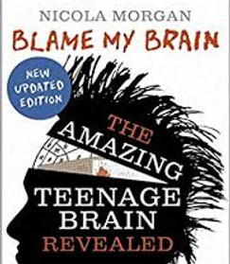

Blame My Brain

by Nicola Morgan​

​

An accessible and humorous examination of the ups and downs of the teenage brain with chapters dealing with powerful emotions, the need for more sleep, the urge to take risks, the difference between genders and the reasons behind addiction or depression.

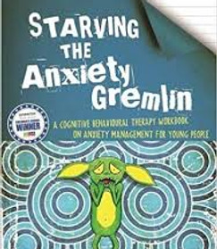

Starving the Anxiety Gremlin

by Kate Collins-Donnelly

​

Starving the Anxiety Gremlin is a resource to help young people understand different types of anxiety and how to manage them using CBT principles that link thoughts, feelings and behaviours.

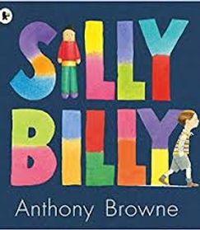

Silly Billy

by Anthony Browne

​

This book takes a sensitive and gentle approach to helping a child cope with anxiety.

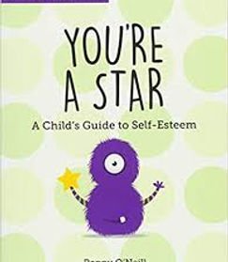

You're A Star

By Poppy O’Neill

​
This practical guide combines proven cognitive-behavioural therapy methods used by child psychologists in schools with simple activities to help your child grow their self-esteem and is aimed at children aged 7–11.

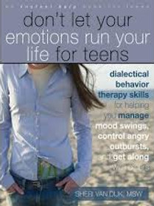

Don't Let Your Emotions Run Your Life

by Sheri Van Dijk

This workbook uses DBT techniques to help teenagers manage their emotions more effectively.

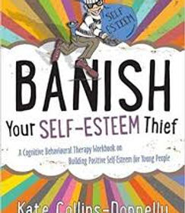

Banish Your Self-Esteem Thief

by Kate Collins-Donnelly

​

An excellent workbook for young people aged 10+ to work through on their own or with the help of a parent or practitioner to develop positive self-esteem.

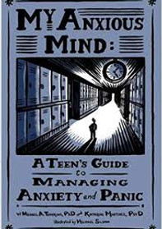

My Anxious Mind

by Michael Tompkins

​

"My Anxious Mind"" helps teens take control of their anxious feelings by providing cognitive - behavioural strategies to tackle anxiety head-on and to feel more confident and empowered in the process.

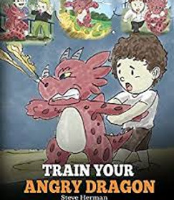

Train Your Angry Dragon

by Steve Herman

​

This book designed for young children helps them understand emotions especially anger and manage this more effectively.

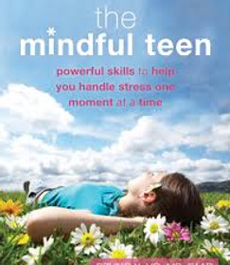

The Mindful Teen

by Professor Dzung X

​

The Mindful Teen offers a unique program based in mindfulness-based stress reduction (MBSR) and mindfulness-based cognitive therapy (MBCT) to help teens deal with stress. The simple, practical, and easy-to-remember tips in this book can be used every day to help young people handle difficult situations more effectively.

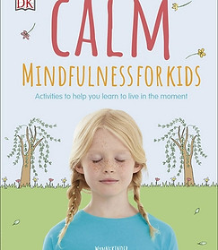

Calm - Mindfulness for Kids

by Wynne Kinder

​

An introduction to mindfulness, this book teaches children how to be mindful by focusing their thoughts and noticing the world around them using fun activities.

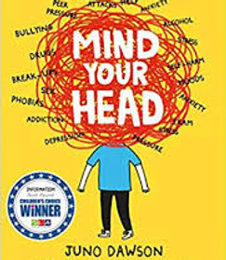
Mind Your Head

by Juno Dawson

​

We all have a mind, so we all need to take care of our mental health as much as we need to take care of our physical health. This frank, factual and funny book talks clearly and supportively about a range of issues facing young people's mental health - whether fleeting or long-term - and how to manage them.
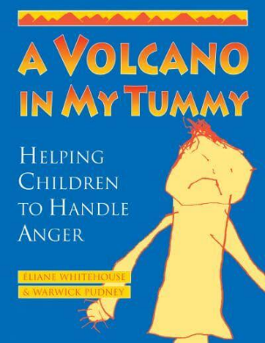

A Volcano in My Tummy Helping Children to Handle Anger
By Warwick Pudney, Éliane Whitehouse
A Resource Book for Parents, Caregivers and Teachers, a Volcano in My Tummy is about helping 6-15 year olds handle their anger so that they can live successfully, healthily, happily and non-violently, with motivation, without fear and with good relationships.

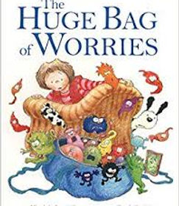

The Huge Bag of Worries

by Virginia Ironside & Frank Ridgers

​

This book helps children see that sharing their problems with others can help them feel better.

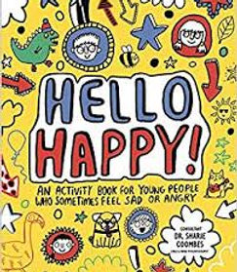
Hello Happy

by Sharie Coombes

​

This book is written by a psychotherapist to help children when they feel sad or angry​.

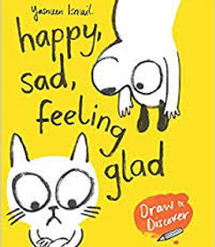
Happy, Sad, Feeling Glad

by Yasmeen Ismail

​

Through activities this book helps children identify activities that may help them and others feel happier.

​

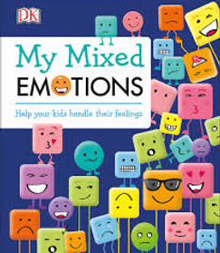
​

​My Mixed Emotions

by DK and Place2Be

​

A book packed with helpful hints, tips, and techniques showing children how to recognise and express their emotions.

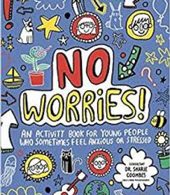

No Worries

by Sharie Coombes

​

This book is written by a psychotherapist to help children manage their worries.

