

School Name

Suicide safety policy (draft)

‘Suicide is a difficult topic and one that hopefully never impacts your school community. The reality, however, is that it does cross the minds of many young people, including school children and young people. In fact, suicide is the leading cause of death among young people and the numbers are alarmingly high. In recent years, up to 200 school children were lost to suicide every year in the UK’ – Papyrus National Charity.
Education and awareness are key to this prevention activity. Papyrus recommends creating a ‘suicide safer school or college policy’ to guide suicide prevention work in your school or college. This includes guidelines on how to prevent suicides, how to intervene with someone who is actively suicidal and how to handle a situation where someone has taken their life, commonly called postvention. It also recommends engaging stakeholders outside the immediate school or college community to help keep a young person safe from suicide.

The policy should remain a live document which is reviewed at least every three years so that it can be continually improved in light of experience.

Author:
Signed:
Date:
Date for review:

Contents
1. Who should be involved in building a suicide safer school or college? 2
2. Statement of purpose 4
3. Our beliefs about suicide and contributory factors 4
4. How we help ensure an active person-centred suicide prevention and intervention policy 5
5. How we help ensure a sensitive and safe suicide postvention provision 8
6. Ongoing support and development of our policy and practice 11
7. Policy Drivers 11
8. Useful organisations 12
9. Appendices 13

1. Who should be involved in building a suicide safer school or college?

Safeguarding is everyone’s business and therefore the whole school community and wider services should be involved in building a suicide safer school/college. This includes:
- Governors
- Senior Leadership Team
- DSLs
- Mental Health Lead
- Parents and Carers
- Counsellors
- Pastoral and Wellbeing Officers
- All Teaching Staff
- All non-teaching staff
- External professionals
- Administrators
- Caretakers
- Catering Staff
- Young people as peer supporters/mentors
- Pupils
- Faith based support teams e.g. Imams, Chaplains.
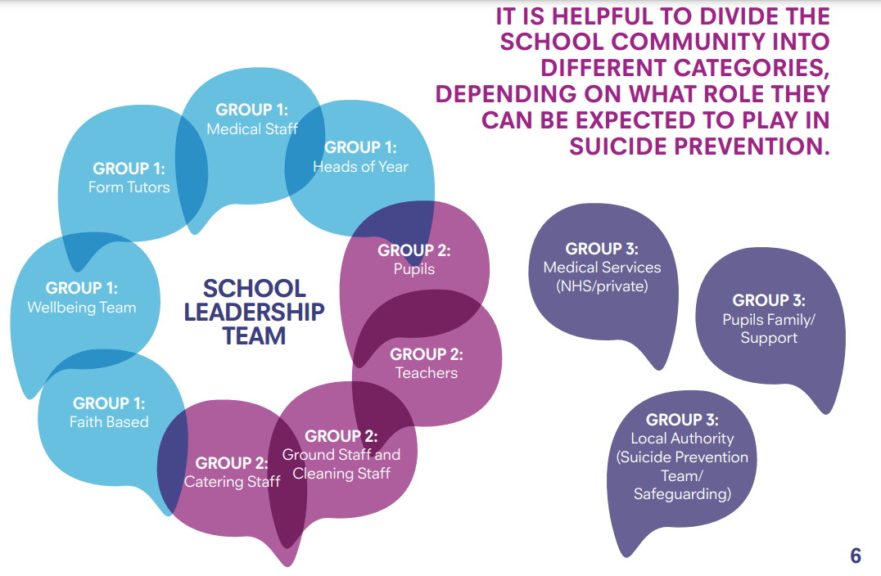
Group 1 | Group 2 | Group 3
People who have explicit responsibility for the mental and emotional well-being of pupils. These people will ideally have taken part in the development of the school’s Suicide-Safer Policy, will be familiar with it and be trained in suicide intervention (for example Applied Suicide Intervention Skills ASIST or Cognus EP training).  As a group we can call them the Suicide Intervention Team.  They include:  - Wellbeing Team  - Medical Staff  - Heads of Year  - Designated person  - Faith Based Support e.g. Imams, Chaplain etc. | People who are an integral part of the school community and can therefore be expected to notice and be compassionate towards pupils who are struggling with thoughts of suicide. This group will be exposed to suicide awareness events and practice. This would increase their willingness and ability to spot the signs that someone is struggling and to signpost them to people in Group 1 for further support.  They include:  - Form Tutors  - Teaching Staff  - Ground Staff  - Cleaning Staff  - Catering Staff  - Pupils | People who are not school staff but have an inherent interest in the wellbeing of the pupils. These people will normally and ideally want to be considered and included in their care/safety plan.  They could include:  - The pupil’s family/ carers/ nominated emergency contact  - Medical Services - NHS or private  - Local Authority Suicide Prevention Boards and Safeguarding Boards as well as local, and in some cases, national Public Health Teams*  - External professional e.g. social works, virtual school

*Please adapt the table above with the names of people who you feel should be in groups 1, 2, and 3 based on your own school community.

2. Statement of purpose

This school or college community is aware that suicide is the leading cause of death in young people and that we play a vital role in helping to prevent young suicide.
We want to make sure that pupils at our school or college are as suicide-safe as possible and that our governors, parents and carers, teaching staff, support staff, pupils and other key stakeholders are aware of our commitment to be a Suicide-Safer school or college.
Reflective questions:
What other important information do you think needs to be included in your statement of purpose?
How does this fit with other policies you may have already? e.g. critical incidents or mental health and wellbeing?

3. Our beliefs about suicide and contributory factors

- Suicidal thoughts are common: We acknowledge that thoughts of suicide are common among young people.

- Suicide is complex: We believe that every suicide is a tragedy. There are a number of contributory factors surrounding a suicide and the reasons are often complex and individual to that person. We are aware there are some vulnerable or marginalised groups where there is uneven distribution of risk, safety, and trust experienced, and it is our role to ensure consideration is given to ensure all groups are supported in our school community. We believe that there are lessons that may be learned from each death that may help prevent future deaths.

- Stigma inhibits learning – stigma can kill: We recognise that the stigma surrounding suicide and mental illness can be both a barrier to seeking help and a barrier to offering help. We recognise that suicidal risk is not experienced equally and that structural factors such as discrimination, stigma, and exclusion may shape vulnerability and help-seeking behaviour and that some groups may be more affected by this than others. This school or college is dedicated to tackling suicide stigma. In our language and in our working relationships, we will promote open, sensitive talk that does not stigmatise and perpetuate taboos and considers the increased risk of different groups within our school community.

- Suicide is everyone’s business: As a school or college community, we recognise that pupils may seek out someone who they trust with their concerns and worries. We want to facilitate the reporting of any risks or concerns.

- Safety is very important: We know that pupils who are having thoughts of suicide may or may not also be behaving in a way that puts their life in danger (suicide behaviours). School children experiencing suicidal thoughts are potentially at risk of acting on these thoughts. Those who are already engaging in suicide behaviours are also clearly at risk of death or harm. This school/college wants to work with our pupils who may be thinking about suicide, or acting on their thoughts of suicide. We want to support them, sometimes working in partnership with family, caregivers and other professionals where this may enhance suicide safety.

- Suicide is a difficult thing to talk about: We know that a pupil who is suicidal may find it very difficult to make their feelings known and speak openly about suicide. We know that some groups may find this more difficult due to potential increased stigma and discrimination. We will provide trained adults who are able to identify when a pupil may be struggling with thoughts of suicide.

- Talking about suicide does not create or increase risk. We will provide our pupils with opportunities to speak openly about their worries with people who are ready, willing and able to support them. We want to make it possible for school children and young people, and those who support them at this school/college, to do so safely. This will be in a way that leads to support and help where this is needed. We will do all we can to refrain from acting in a way that stops a pupil seeking the help they need when they are struggling with thoughts of suicide.

- Those with personal experience have a unique role to play in the development and refinement of this Suicide-Safer Policy: We will endeavour to involve anyone from our community who has personal experience of suicide, either having struggled themselves or supported someone with thoughts of suicide.

4. How we help ensure an active person-centred suicide prevention and intervention policy
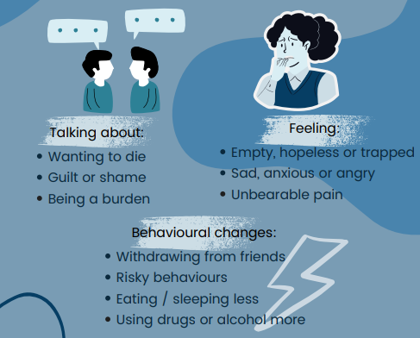
Warning signs
There are a number of warning signs that may indicate a person is experiencing suicidal thoughts. This is not an exhaustive list and needs to be consider alongside the contextual factors known about the person. Warning signs should be seen as an invitation by the person to receive support or help.

Risk and protective factors
Suicide rarely occurs as a reaction to a one-off event and is more likely to follow a cumulative series of events of factors known as stacking. A single event may act as a final straw. There are some groups within our community that may be at increased risk of experiencing suicidal ideation and it is important that we consider the intersectionality of different factors that may affect a young person. For example, recognition of how suicide risk intersects with racism, LGBTQ+, disability and neurodivergence, care experience, poverty, housing insecurity, migration status, and faith-based stigma.

Additionally, the following risk factors were identified in a recent study that looked at children and young people who had died by suicide:

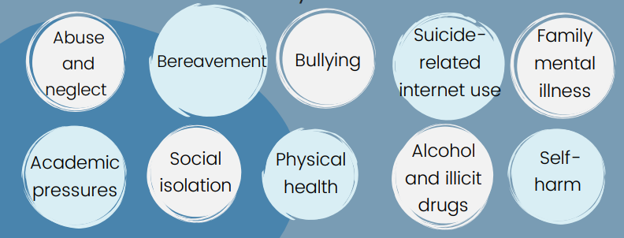

- Our school or college has a named individual who is responsible for the design, implementation and maintenance of this policy.

- Our school or college has a Suicide Intervention Team edit whose members understand this policy and are trained in Suicide Intervention. We will ensure that a team of ( ) people have undertaken Suicide Intervention Training so that at least ( )* trained staff are on duty during our school or college opening hours. The Suicide Intervention Team will be the point of escalation for any concerns about a pupil or young person. The Suicide Intervention Team will keep confidential records of pupils at risk of suicide to ensure some continuity of care within the intervention model. The team consists of:

    - Name
    - Name
    - Name

- We will endeavour to ensure that all our staff are suicide aware. This means that all staff CPD will include suicide awareness, i.e. how to spot signs, what to do and how to escalate any concerns to the Suicide Intervention Team. Edit how you will do this e.g. through staff meetings, bulletins, INSET days, suicide awareness days

- We will ensure that all pupils are suicide aware. This means that we will ensure there is an annual programme of awareness-raising events and campaigns that equip our pupils to know how to spot signs, what to do and how to escalate any concerns to the Suicide Intervention Team. For example:

    - Workshops
    - PSHE curriculum
    - Through curriculum (ask subject leaders)
    - Assemblies

- Confidentiality - In order to protect life whenever we have serious concerns for the welfare of a pupil we will break confidentiality and share information with the necessary services, including emergency services.

- We recognise that pupils may experience periods of poor mental health while attending our school or college. We will endeavour to put in place mechanisms which allow staff that have regular interaction with the pupil to be able to flag or review any concerns about individual pupils including suspected suicidal thoughts. Ideally this flagging will be electronic and immediate e.g. ‘My concern’ feature on the school or college intranet home page. Pupils that are flagged in this way will be reviewed regularly and routinely by nominated staff so that patterns of concerning behaviour can be spotted and the necessary steps can be put in place to keep them safe, including meeting them face to face. Add safeguard system

- When we identify a pupil at risk of suicide and decide to engage external services, such as a hospital A&E department or a crisis centre, we will have explicit guidelines on the pathways that apply. Those guidelines will be developed in co-operation with the external services, and will be reviewed regularly as the provision of such services change over time.

- We recognise that some pupils may relocate to the school or college community when they join us but that they will still spend long periods of the year at home. We will look at ways we can help make the medical support they need (medication, counselling) consistent so that the pupil has a continuity of care.

- We will develop a ‘Helpers in the Community’ document (see template Appendix A). This will inform and equip our community about help that is available locally and nationally to support someone who is experiencing poor mental health and emotional wellbeing.

Helpful language
Using sensitive language can help to build understanding and increase empathy. Helpful language also avoids judgement.
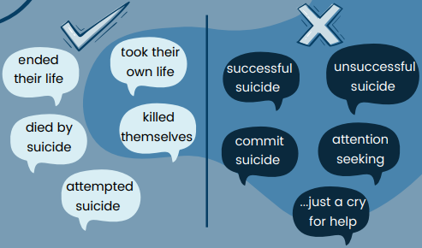Reflective questions:
- Who is the named person taking responsibility of this policy?
- Who is in the safeguarding team and what training/support do they need?
- What training/communication is required in your school for groups 1, 2, and 3 to raise awareness of these beliefs in your school community?
- How will you circulate to staff key information regarding helpful and unhelpful language?
- What physical safety adaptations need to be made in your environment?
- How do you seek views of young people and families to represent all groups within your school community?
- In what ways can you ensure that marginalised groups feel safe to share their views and seek support?
- How will you monitor risk and protective factors for YP to identify those ‘at risk’ of suicidal ideation?
- What processes will be in place to spot warning signs?
- Who will be the key people involved in working with a YP where it has been identified they have suicidal thoughts? Importance of asking about suicide.
- Who needs to be involved in developing a safety plan? Do you have a safety plan proforma (see examples)
- How will you liaise with external agencies?

5. How we help ensure a sensitive and safe suicide postvention provision

- Our school or college has a Suicide Postvention Team whose role it is to respond in the event of a suicide. Each member of our Suicide Postvention Team will have a defined responsibility within our plan including leadership, family liaison and any communications with external agencies, including the media.

- We will be clear about how we deal with an inquest after someone has died by suicide in our school or college. We will support the authorities in their work but will be mindful of the distress an inquest causes to the bereaved people. We will also be mindful of the impact supporting an inquest can have on staff.

- We will record and monitor deaths by suicide and the impact on the community. This will include on-going monitoring of pupil deaths including suicides, suspected suicides and, if possible, self-harm. Monitoring of self-harm might be done through the collection of information from pupil support services and pupil health services.

We will also consider:
- Recording and monitoring the uptake of bereavement support services by pupils after a suicide
- Surveying pupils regarding how supported they feel
- Assessing the impact of interventions on staff
- Reviewing lessons learned and any suggested changes to procedures and provision of well-being services
- Identification of multiple events, such as two suicides in a relatively short period of time (e.g. one term) which may indicate a possible suicide cluster, including investigating possible connections between individuals, their circumstances and their suicidal behaviour. Multiple suspected suicides may not be connected, but their occurrence can nonetheless have consequences. For example, in some vulnerable individuals it may contribute to thoughts of suicide as a way of dealing with problems. Where concerns arise regarding a possible suicide cluster we will immediately communicate with the local authority Public Health Suicide Prevention Lead* and collaborate closely with them to development a response plan.

Suicide contagion
People who have lost someone to suicide are at a greater risk of suicide. This is sometimes called suicide contagion. The vulnerability model might be helpful in identifying those pupils that are particularly at-risk.
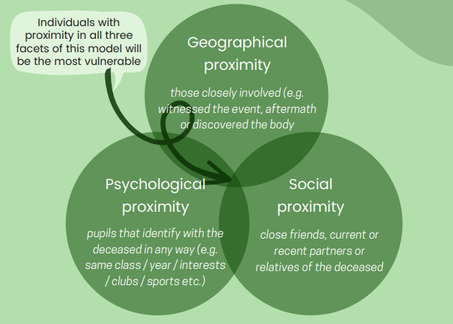
Information sharing in an appropriate way – find out a bit existing protocol e.g. child death protocol
Think about the who and when… very specific (create a table of who will do what and when?)
- Who will take the lead in postvention planning and implementation?
- What do you think should be prioritised immediately?
- What do you think should be prioritised in the first 24 hours?
- What do you think should be prioritised in the first month?
- How will you circulate to staff what they should and shouldn’t say?
- How will you communicate honestly about the occurrence of multiple deaths? (consider goldilocks principle)
- How will you identify groups that might need early support (including staff groups)? E.g. RAG rating.
- How will you consider groups that may intersect with the identity of the person who has died by suicide such as their race, faith, LGBTQ+, or socio-economic status?
- How will you provide increased resources for pupils with mental health difficulties who may be at risk? What will you need to consider to reduce academic stress where possible?
- How will you share positive messages about available help and recovery?
- In what ways could you support pupils through memorials while at the same time avoiding glamourising death or institutionalising grief?
- What needs to be considered to support with anniversaries, events, and milestones (e.g. not romanticising death, not erecting permanent structures and giving people safe space to remember but not re-live).

Action plan following a suicide
Timeframe | What needs to happen | Who will take the lead? | Who will it involve?
Immediately | - actions | Named person for each action | Name the groups it will involve / affect
In the first 24 hours
In the first week
In the first month
Milestones (e.g. significant dates)
Anniversaries

6. Ongoing support and development of our policy and practice

- Our Leadership Team will ensure that ongoing reviews take place, that processes are updated in line with best practice and that on-going training is undertaken when necessary.

- Where possible we will include or consult with members of our community who have personal experience of suicidal ideation, either their own or as a concerned other, in the design, development and continuous refinement of this policy.

- We will refresh and update our ‘Helpers in the Community’ document on an annual basis, and we will share it across our community as part of our regular suicide awareness raising campaigns.

7. Policy Drivers

Educational Psychology Service Critical Incident Guidance
Guidance
Educational-Psychology-CI-Guidance-2022.pdf (cognus.org.uk)
Protocol
EPS-Protocol-September-2022.pdf (cognus.org.uk)
Guidance
Suicide prevention: developing a local action plan https://www.gov.uk/government/publications/suicide-prevention-developing-a-local-action-plan
Preventing suicide: lesbian, gay, bisexual and trans young people
Preventing suicide: lesbian, gay, bisexual and trans young people - GOV.UK (www.gov.uk)
Suicide prevention: identifying and responding to suicide clusters
Suicide prevention: identifying and responding to suicide clusters - GOV.UK (www.gov.uk)
Suicide prevention: suicides in public places
https://www.gov.uk/government/publications/suicide-prevention-suicides-in-public-places
Support after a suicide: a guide to providing local services https://www.gov.uk/government/publications/support-after-a-suicide-a-guide-to-providing-local-services
Policy
Suicide prevention strategy for England
https://www.gov.uk/government/publications/suicide-prevention-strategy-for-england
Suicide prevention: third annual report
https://www.gov.uk/government/publications/suicide-prevention-third-annual-report

8. Useful organisations

Organisations
Papyrus: Prevention of young suicide: Papyrus UK Suicide Prevention | Prevention of Young Suicide (papyrus-uk.org)
Suicide Prevention UK: SPUK - Suicide Prevention UK Charity 1187866
Samaritans: Samaritans | Every life lost to suicide is a tragedy | Here to listen
Helplines
Samaritans. To talk about anything that is upsetting you, you can contact Samaritans 24 hours a day, 365 days a year. You can call 116 123 (free from any phone), email jo@samaritans.org or visit some branches in person.
SANEline. If you're experiencing a mental health problem or supporting someone else, you can call SANEline on 0300 304 7000 (4.30pm–10.30pm evcery day).
National Suicide Prevention Helpline UK. Offers a supportive listening service to anyone with thoughts of suicide. You can call the National Suicide Prevention Helpline UK on 0800 689 5652 (6pm to midnight every day).
Campaign Against Living Miserably (CALM). You can call the CALM on 0800 58 58 58 (5pm–midnight every day) if you are struggling and need to talk. Or if you prefer not to speak on the phone, you could try the CALM webchat service.
Shout. If you would prefer not to talk but want some mental health support, you could text SHOUT to 85258. Shout offers a confidential 24/7 text service providing support if you are in crisis and need immediate help.
The Mix. If you're under 25, you can call The Mix on 0808 808 4994 (3pm–midnight every day), request support by email using this form on The Mix website or use their crisis text messenger service.
Papyrus HOPELINEUK. If you're under 35 and struggling with suicidal feelings, or concerned about a young person who might be struggling, you can call Papyrus HOPELINEUK on 0800 068 4141 (24 hours, 7 days a week), email pat@papyrus-uk.org or text 07786 209 697.
Nightline. If you're a student, you can look on the Nightline website to see if your university or college offers a night-time listening service. Nightline phone operators are all students too.
Switchboard. If you identify as gay, lesbian, bisexual or transgender, you can call Switchboard on 0300 330 0630 (10am–10pm every day), email chris@switchboard.lgbt or use their webchat service. Phone operators all identify as LGBT+.

9. Appendices

Could put in infographics or where they can be found in your school
Appendix A
Local/ national services that can help deal with the underlying causes of suicidal thoughts:
Rape and/or sexual assault .......................................
Domestic violence hotline ........................................
Child abuse hotline ....................................................
Police/ambulance/fire services ...............................
Hospital emergency services ...................................
24 hour medical advice ..............................................
Homelessness emergency .......................................
Accommodation ..........................................................
Mental health outreach clinic ...................................
Child and adolescent mental health service .........
Sexual health and screening ....................................
Sexuality support........................................................
Children’s services .....................................................
Family support services ............................................
NHS counselling support ..........................................
Alcohol and substance misuse ................................
Carer support services ..............................................
Religious/spiritual support .......................................
Legal assistance/victim-witness assistance .........
Probation officers .......................................................
Debt advice .................................................................

