**Anxiety**

Anxiety is something that **everyone** experiences. It is our body’s natural reaction to stress or danger. Anyone can experience anxiety; we all feel anxious from time to time.

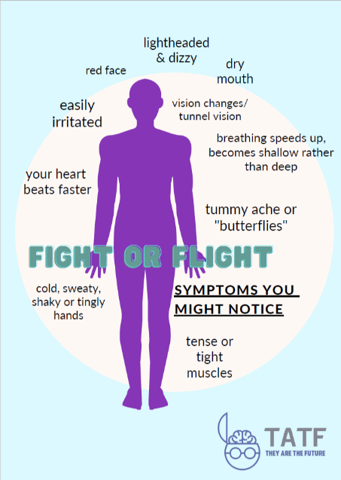Millions of years ago, the fight, flight or freeze response was developed to keep ourselves safe. This in-built mechanism has evolved over the years and warns us when we are in danger. This alarm triggers us to either fight a situation, run away from it or freeze.

When we experience this response, it can feel extremely uncomfortable in our bodies. There are many different symptoms the fight or flight response can trigger.

It is important to not everyone experiences these body symptoms differently. How one person experiences anxiety may not look the same for other people.

The body sensations can make individuals feel like they are in physical danger. It’s important to remember you are not, it is just your fight or flight response kicking in.

Although everyone experiences anxiety, individuals that have experienced trauma in their lives may be prone to feeling more anxious than others. Trauma can change how individuals experience the world.

**Trauma and the brain**

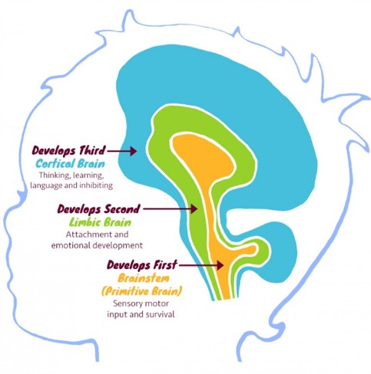The brain develops from the **bottom up**, and the brain stem develops first. The brain stem is responsible for keeping us safe; it sends signals to the body to enter the fight, flight or freeze mode.

When children experience chronic stress, their fight/flight/freeze response may always be on high alert, ready to try and keep themselves safe.

The limbic brain (as seen in the image) is an area of the brain vital for processing emotions. It activates the fight/flight/freeze response. When children are always heightened and experiencing increased anxiety, it takes a lot to feel safe and secure, especially in relationships with other adults.

The top part of the brain continues growing into late twenties. This is the part of the brain where academic learning takes place. To be able to focus, make mistakes and learn from requires all parts of the brain to be calm. When they are activated, individuals are heightened and cannot remain calm.

Children that have experienced chronic stress and trauma will be more heightened, and experience the fight or flight response quicker than children without a traumatic background would.

**How does anxiety present?**

|  |  |
| --- | --- |
| **Fight: self-preservation at all costs**   * Explosive temper and outbursts * Aggressive, angry ​ * Controlling of others ​ * Can’t hear others points of view * Demands perfection from others ​ * Wanting to hurt self/others * Getting into physical fights with others in the playground/siblings/others at home | **Flight**   * Feelings of panic and anxiety ​ * Rushing around ​ * Can’t sit still or relax ​ * Obsessive and or compulsive behaviour​ * A need to control small elements of situations * Needs things to be perfect * Leaving any situation they are in (classroom/home/out with others) |
| **Freeze**   * Spacing out, disassociation – brain fog * Isolating self from the outside world ​ * Difficulty making decisions ​ * Not able to accept achievements ​ * Wants to hide ​ * Might look like low mood | **Fawn**   * People pleasing * Scared to confront, over caring |

Although anxiety can feel overwhelming, there are tools and strategies to help cope with the feelings.

Please see the **Regulation document** for more information on this.

**If anxiety feels like it is becoming overwhelming and you or someone you know is finding it hard to cope, please contact your school pastoral/mental health team.**

**Please contact the Cognus Educational Psychology Service for more information.**