

Cognus 2025 

*Demand Avoidant Profiles*

Guidance Document

# 

# Aims of guidance

The following document has been written to provide guidance to professionals in Sutton who are responsible for supporting children and young people who present with demand avoidant behaviours. It is hoped this document will empower schools, families and professionals through providing a clear understanding of extreme demand avoidance, compared to expected levels of boundary pushing, which is shared across the local area.

This document has been co-produced by Cognus teams including the Educational Psychology Service, Autism Support, Clinical Psychology Service, and Therapies Service, and endorsed by The Link School. Much of the following information has been drawn from the PDA Society, The Link School website, and the growing research evidence base.

# What is Pathological Demand Avoidance (PDA)?

## History and debate of PDA

The term ‘Pathological Demand Avoidance’ (PDA) was first conceptualised and described by Elizabeth Newson and colleagues in Nottingham in the 1980s to describe a group of children who were being assessed for Autism/Asperger’s syndrome but presented with features not considered typical for these conditions at that time. In current practice, some professionals and organisations, such as the PDA Society, continue to advocate for PDA as a distinct profile or neurotype.

However, other organisations, such as the National Autistic Society, view the behaviours associated with PDA as typical for those on the Autistic spectrum. In fact, Gillberg et al (2015) found that 1 in 5 autistic children showed significant demand avoidant traits, which dropped to1 in 50 during adolescence suggesting that demand avoidance may become less pronounced with age. Similarly, Green et al (2018) highlight the limited validity of PDA as a distinct syndrome. It is argued that using PDA as a label can imply the difficulties are within the person and not created by wider environmental factors and overall it is important that individuals’ own lived experiences are considered.

This divergence reflects the evolving understanding of neurodevelopmental profiles and the complexities of categorisation in clinical practice. A significant challenge is that currently there is little research into the characteristics of demand avoidance profiles and neurodivergence and the research that does exist is generally of low quality, which Kildahl et al (2021) systematic review of 13 studies concludes.

## Definition

PDA is a term used by some to describe a particular profile of autism characterised by extreme demand avoidance driven by high levels of anxiety. However, PDA does not currently appear in diagnostic manuals such as the **DSM-5** or **ICD-10/11**, and its formal recognition remains a subject of debate within the medical and psychological communities ( as above).

In Sutton, our approach focuses on meeting the needs of children and young people who display extreme demand avoidant behaviours, regardless of whether these are formally labelled as PDA. The strategies and interventions outlined in this document are grounded in evidence-based practices and tailored to support individuals with high anxiety and demand avoidance behaviours', aligning with our commitment to providing inclusive and person-centred support.

By prioritising the needs of the child over diagnostic labels, we aim to:

* Recognise the individuality of each young person.
* Provide effective strategies that reduce anxiety and promote well-being.
* Empower schools, families, and professionals to collaborate and respond flexibly to these unique challenges.

# Anxiety

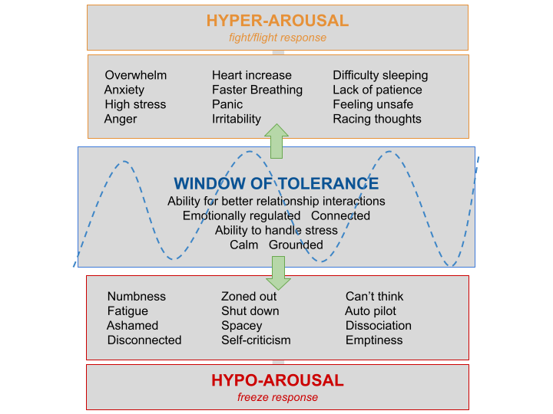For children with a demand avoidant profile, the avoidance of demands should be seen in the context of the heightened anxiety the young person is experiencing. In particular, Moore et al (2020) highlight that it is best understood as an understandable and rational response to the circumstances that an autistic child finds themselves when navigating a neurotypical world.

**A window of tolerance** refers to each person’s capacity to think, learn, and engage. For these young people, very simple demands can push them outside their window of tolerance, resulting in a fight, flight, or freeze response (Herschler, 2021).

Based on the neuroscientific research, when a young person experiences significant levels of anxiety, their amygdala (the part of the brain linked to emotions) can be oversensitive, and therefore very small triggers (demands) result in them ‘flipping their lid’, becoming dysregulated and presenting with a visible stress response (Siegel & Bryson, 2018).

Figure 1: Window of Tolerance

When this happens, the pre-frontal cortex (the part of the brain linked to thinking, reasoning, and problem-solving) becomes ‘offline’, making it difficult for them to engage. There may be times the young person is comfortably within their window of tolerance and therefore they can cope with some level of demand. However, if their anxiety is heightened, a small demand may push the young person out of their window, and their survival responses kick in. Young people with a demand avoidance profile can experience a demand as a (perceived) threat to their autonomy and control which activates their fight, flight, freeze response. It is important to be aware the trigger can be an internal biological demand such as hunger or needing to go to the toilet as well as external such as an instruction or comment. It is therefore important to monitor and assess the young person’s anxieties to consider the level of demand they can tolerate at one time.

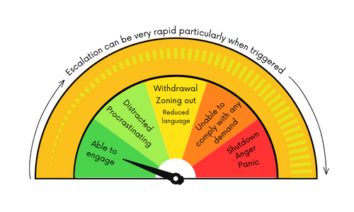

Figure 2: Emotional regulation tool

**Spoon theory** (created by Christine Miserandino in 2003) is based on the idea that individuals wake up each day with a set number of spoons that symbolise the amount of energy and tolerance levels that they have. Factors within the environment and demands placed on them can deplete these spoons rapidly, leading to fatigue and emotional dysregulation. Dependent on the wide-ranging factors across a day, a child may use up more or less spoons, resulting in varying levels of tolerance to demands. For some children, they may have very few spoons left by the time they start school in the morning, resulting in them moving out of their window of tolerance very quickly when a demand is placed on them, whereas on another morning they may have more spoons at their disposal.

This analogy can be a helpful way to explain to young people, families, and staff about how an autistic child with an extreme demand avoidance profile may experience their day in a visual, concrete way. This analogy also helps to explain the fluctuating tolerance levels of young people who may be able to tolerate more on some days than others.

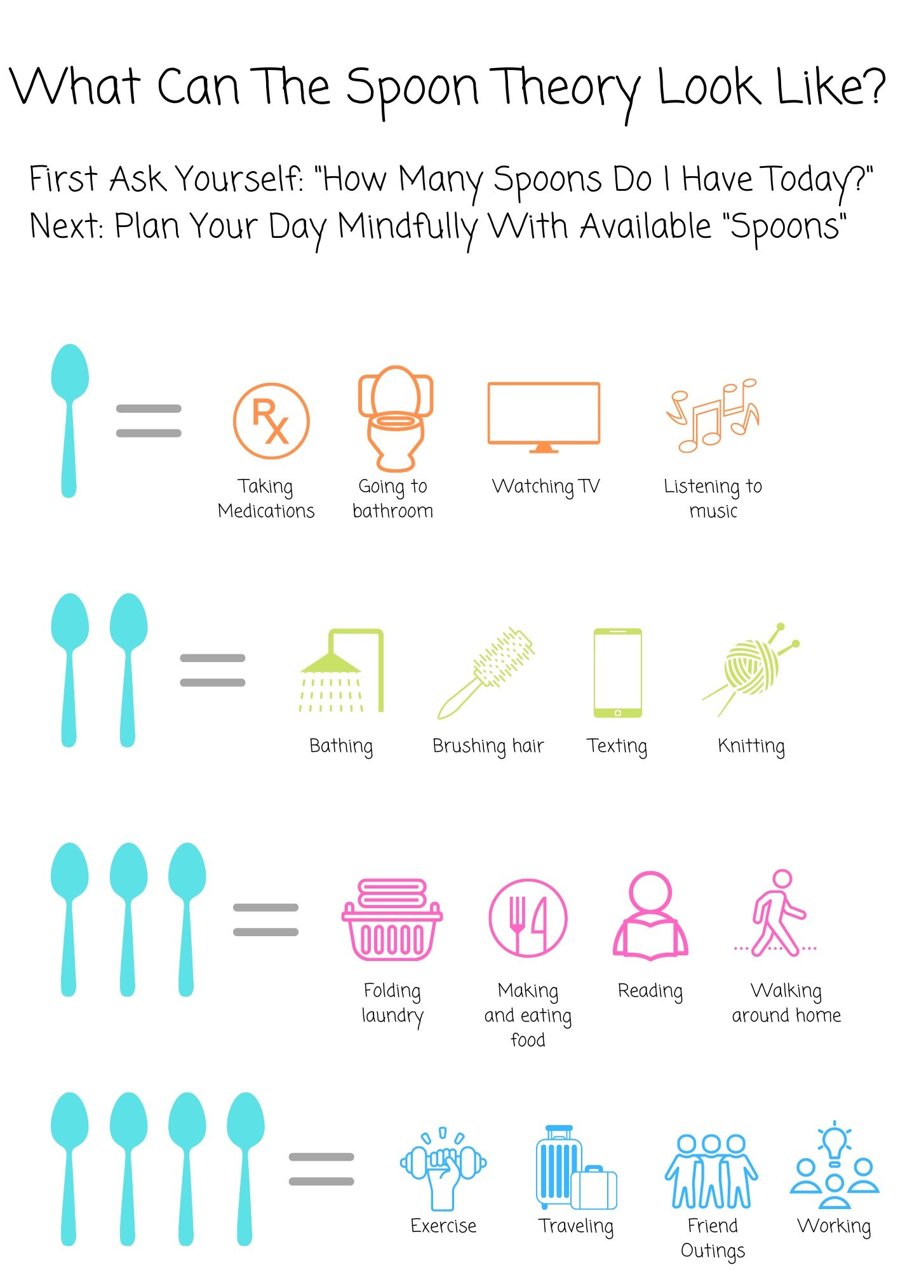

Figure 3: Spoon Theory

## Strengths of individuals with an extreme demand avoidant profile

In addition to some of the challenges experienced, it is important to note the strengths of an individual with an extreme demand avoidant profile.

* They can often show advanced verbal skills to articulate needs, express opinions and advocate for themselves.
* They can have very good negotiation strategies.
* They can often display remarkable resilience and determination.
* They can often show exceptional creativity and imagination. They may think outside the box, approach problems with unconventional solutions and exhibit innovative thinking.
* They can often show very good attention to detail and observational skills.
* They can speak honestly and directly which can open helpful discussion.

## Assessment

PDA does not currently appear in diagnostic manuals (DSM-V, ICD-10/11) and is not recognised within the Southwest London and St George’s NHS Trust. Therefore, it cannot be formally given as a separate diagnosis to Autism. However, some professionals differentiate in their reporting between autistic individuals and autistic individuals with an additional demand avoidance profile which can be associated with PDA.

|  |
| --- |
| *When a child is being assessed for Autism by the Cognus Clinical Psychology Service and presents with characteristics in line with a PDA profile, this will be shared during the assessment and labelled as* ***Extreme Demand Avoidance.*** |

Within the Cognus Clinical Psychology Service, the following would be considered as part of an autism diagnosis to consider a potential demand avoidant profile.

### Key Characteristics

It is important to note that everyone experiences ‘demand avoidance’ (resistance to doing something that is requested or expected of you) sometimes. However, here we use demand avoidance to mean the characteristic of a persistent and marked resistance to 'the demands of everyday life’, which may include essential demands such as eating and sleeping as well as expected demands such as going to school or work.

Some of the key characteristics include:

1. **R**[**esists and avoids**](https://www.autism.org.uk/about/what-is/pda.aspx#resists) **the ordinary demands of life.**

There are many types of demands:

|  |  |
| --- | --- |
| A direct demand | An instruction, such as ‘brush your teeth’, ‘put your coat on’ or ‘complete your tax return’ |
| An internal demand | Willing yourself to do something, bodily needs such as hunger or needing the toilet, personal hygiene, or taking medication |
| An indirect or implied demand | Including any expectation, such as a question that requires an answer, food in front of you that you are expected to eat, observing manners, or participating in celebrations |
| A demand in a demand | Going to cinema can be a demand in a demand, sitting and sitting quietly, eating, watching etc |

Activities individuals love to do can also be demands, so doing the thing the love or refusing to do it, can cause some individuals to have a meltdown even if they have chosen to complete activity during, or after they finish the event

For some, avoidance may seem their greatest social and cognitive skill and the strategies they use are essentially socially strategic. These can include:

* Distracting the person making the demand
* Acknowledging the demand but excusing themselves
* Procrastination and negotiation
* Physically incapacitating themselves
* Withdrawing into fantasy
* Physical outbursts or attacks.

Underpinning this avoidance is an anxiety about conforming to social demands and of not being in control of the situation. People with other autism profiles may also react to social demands by becoming avoidant but tend to do this in ways that aren't very social in nature e.g. ignoring, withdrawing or walking away.

1. **A**[**ppears sociable**](https://www.autism.org.uk/about/what-is/pda.aspx#sociable)**, but lacks understanding.**

People with a demand avoidant profile tend to:

* Appear social at first and be 'people-orientated'.
* Have learnt many social niceties and may decline a request or suggestion politely.
* Seem well tuned in to what might prove effective as a strategy with a particular person.
* Be unsubtle and lack depth – they can be misleading, overpowering and may overreact to seemingly trivial events.
* Have difficulty seeing boundaries, accepting social obligation and taking responsibility for their actions.
* Display confusing behaviour and contradictory moods, e.g. hugging becomes pinching or a child may embrace their parent while saying something like "I hate you".
* As children, lack a sense of pride or embarrassment, and behave in uninhibited ways.
* As children, fail to understand the unwritten social boundaries that exist between adults and children and can become overfamiliar or bossy.

3. **Experiences** [**excessive mood swings**](https://www.autism.org.uk/about/what-is/pda.aspx#mood) **and impulsivity**

* Difficulty with regulating emotions is common in autistic people, but [early studies](http://adc.bmj.com/content/88/7/595.full) found it especially prevalent in people with a demand avoidant profile. They may switch from one mood to another very suddenly in a way that can be described as "like switching a light on and off".
* To other people, the emotions can seem very dramatic and over the top, like an act, and there’s sometimes no obvious reason.
* But this switching of mood can be in response to perceived pressure or a demand and is driven by the need to control.

**4. Appears** [**comfortable in role play**](https://www.autism.org.uk/about/what-is/pda.aspx#roleplay) **and pretence (escapism) and use a lot of babyish language.**

* People with a demand avoidant profile, especially children, are often highly interested in role play and pretend, sometimes to an extreme extent. They will often use role play or pretend as part of a strategy to avoid demands or exercise control. When they become involved in play scenarios with other people, they will nearly always try to direct play and this can cause real conflict, especially with other children. This was recognised early on as being different from many other children on the autism spectrum.
* Children with a demand avoidant profile often mimic and take on the roles of others, extending and taking on their style, not simply repeating and re-enacting what they may have heard or seen in a repetitive or echoed way.

**5. Displays** [**obsessive behaviour**](https://www.autism.org.uk/about/what-is/pda.aspx#obsessive) **that is often focused on other people**.

* Strong fascinations and special interests pursued to an 'obsessive' degree are very characteristic of people with all autism profiles. However, it has been noted that the demand avoidant behaviour itself usually has an ‘obsessive feel'.
* People with a demand avoidant profile may have a strong fascination with pretend characters and scenarios or real people they interact with. This can result in blame, victimisation and harassment that cause problems with peer relationships.

# What do young people say?

 In the book *‘Pathological Demand Avoidance Syndrome - My Daughter is Not Naughty’* by Jane Sherwin, the following quotes by young people were shared:

“I even find it difficult to engage in things I enjoy if it has been suggested by someone else”

“Pushing me to comply can result in such panic that I may lash out or have a meltdown.”

“My anxiety stops me from doing the things I want to do as well as the things I don’t want to do.”

“Not being able to do so many things that I would like to do is as frustrating for me as it is for you!”

The following provides a list of strategies as effective in managing the behaviour of children, teenagers and young adults with PDA, created by YP with a demand avoidance profile (Jane Sherwin 2014).

|  |  |
| --- | --- |
| Don’t | Do: |
| * Speak down to me or patronise me * Don’t give me direct demands * Don’t give me ultimatums * Do not state the obvious * Do not bombard me with questions * Do not insist that I respond or answer you | * Try to build a relationship with me and talk about the things I chose to talk about * Do speak to me as an equal * Do offer me choices * Do empathise with me * Do understand that I want to do things, but my anxiety stops me * Do recognise the signs of my anxiety and pull back when you see them |

In further developments of this guidance, it is hoped to explore the views of young people and their families locally to gain further insight into their lived experiences.

# How can we support?

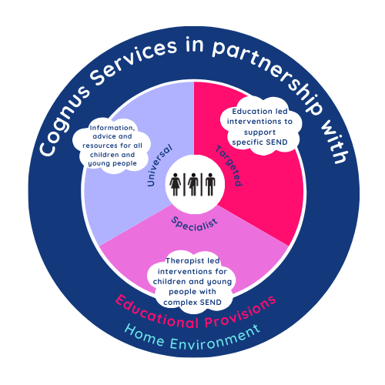There is a growing (albeit limited) research base for strategies and interventions for young people who present with demand avoidant behaviours. This evidence suggests that a personalised, flexible and non-confrontational approach which avoids escalating emotion reactivity tends to be most effective (O’Nions et al., 2020).

It is important that support for young people with a demand avoidant profile should be delivered in line with the graduated response where universal strategies are embedded within everyday interactions, followed by targeted intervention for those with increased difficulty, and specialist support for the minority with a high level of need, all underpinned by a relational and neuroaffirming ethos. All support should be used in line with assess, plan, do review cycles with consideration of preparing for adulthood.

Figure 4: Cognus graduated response

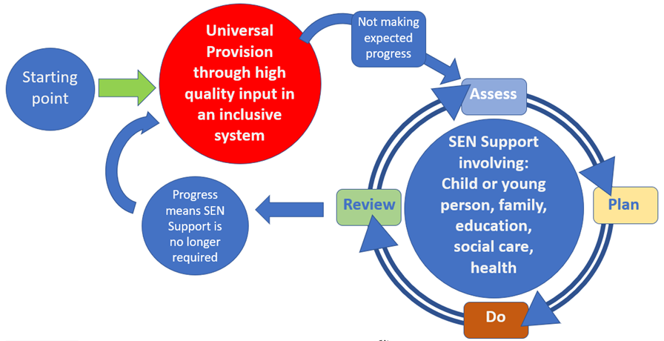

Figure 5: Assess, plan, do, review cycle

## Universal strategies

It is highly important that universal strategies are embedded at a whole school approach within a school culture and ethos of inclusivity for neurodiverse young people. Therefore, schools should consider their own practices and ways in which to develop neuro-inclusive environments and support staff in working with young people with a demand avoidant profile. The following section provides an overview of key strategies and principles to implement as a school wide policy and schools may wish to request whole school training.

### Relationship building/a relational approach

Relationships are a central component to support young people to feel safe, supported and connected – key aspects to reducing anxiety levels and increasing feelings of safety and belonging. Therefore, staff should place emphasis on building positive and trusted relationships and prioritising relational experiences above task completion and curriculum planning. If staff can work hard to get to know and understand a pupil, and show interest in their hobbies and skills, the young person is more likely to feel safe within their company. A key model to develop relationships is that of the PACE approach created by [Dan Hughes](http://www.danielhughes.org/home.html) . It is important to use these attributes when interacting with students each day to develop positive relationships and seek to gain an understanding of their experiences.

### PANDA model

The [PDA society](https://www.pdasociety.org.uk/) suggest that conventional support often recommended for those with autism based on firm structures, boundaries, and reward/consequences are less effective, and instead a person-centred approach based on negotiation, collaboration, and flexibility is required. The PANDA acronym symbolises the need to tailor the environment to meet needs in five key principles: Picking battles, Anxiety management, Negotiation and collaboration, Disguise and manage demand, and Adaptation.

Effectiveness of strategies and approaches will vary for different young people based on their own experiences and anxieties and therefore a tailored approach will be required with regular reviews of support to maximise impact. A pupil profile/passport can be a helpful way to share what works best for an individual young person.

|  |  |
| --- | --- |
| Pick battles | * Move on quickly from incidents. * Don’t dwell on bad behaviour. * Every new day, afternoon, or lesson is a clean slate. The ‘next face’ breezes in as though nothing has happened. * Use a network of support - don’t be the one to field the meltdowns all the time. |
| Anxiety management | * A flexible approach to behaviour based on knowledge of child’s anxiety levels and how this relates to their level of demand avoidance. * What does each number feel like, look like and what can I do? * Use regular physical learning breaks to allow time to let off steam. * Remember a BIG incident requires a LONG recovery period. Don’t expect the child to return to a task, to school or to regulate within a few hours. * Be aware of the child’s sensory profile. A calming space to retreat to with music or variable lighting can have a significant impact on their ability to cope with a bad day. * An emotional wellbeing and social curriculum/intervention e.g., role play to help model and practice communications and interaction skills, coaching, and strength-based social skills activities. * Use the child’s interest to create puppets. These can then be used as puppets to act out scenarios. |
| Negotiation and collaboration | * Treat the young person as an equal. * Give choices of where or how something will happen rather than whether it actually happens. Be aware choices can also be a demand for some. * Language used to present tasks should also be carefully thought out; “I need help to do this. . .”, “I wonder if you could …”, “Would it be a good idea to . . .?”, “Our next mission is to . . .” or “Let’s investigate.” * Calm, reasoned explanations about why and how things need to be done, allowing room for negotiation and compromise. |
| Disguise and manage demand | * Shifting the blame for a safety rule to a governing statute or community law helps to maintain the relationship with the adult that must enforce the rule. * Present a choice, contract or demand and then allow time for processing without nagging or repetition. It may take a while for all the options to be internalised. * Use of other communications methods – such as writing, drawing or using messaging technology – in addition to or instead of verbal communications. * Thinking aloud ‘I think it may be time to sit on the carpet soon’. * Put work in a box so the pupil has control over ‘discovering’ it and seeing what’s inside. * Have a variety of projects on the go simultaneously so the pupil can choose which one to work on. * Equipment stored close by to be used when needed as laying out equipment can be seen as a demand. |
| Adaptation | * Try and diffuse situations with humour. * Indirect praise ‘ I liked the way…. Helped Sarah’. * Trying to present work in creative ways * Personalised learning. |

## 

## Targeted intervention in school

Some young people will need additional support and intervention in school to meet their needs related to anxiety. It is important that additional targeted intervention supplements rather than replaces the universal provision outlined above.

One way to provide increased support is to consider which demands across a day should be negotiated e.g. picking your battles. To achieve this, it can be helpful to outline all the demands the young person may experience at school, home, and within their health which lead to anxiety-based demand avoidance responses. Then, consider whether the demand is:

* High priority (non-negotiable)
* Desirable but not essential
* Low priority (negotiable)

The following example has been provided by the Link school.

|  |  |  |  |  |  |
| --- | --- | --- | --- | --- | --- |
| **School demands** |  | **Home demands** |  | **Health demands** |  |
| Wear school uniform |  | Go family food shopping |  | Wash self/ allow other to wash them |  |
| Attend assemblies |  | Get in the car to take a sibling to a club or party |  | Visit a dentist for a checkup |  |
| Sit in a planned seating pattern |  | Attend a special family event |  | Attend a CAMHS appointment |  |
| Go to the playground and set playtimes |  | Attend an emergency medical appointment |  | Take prescribed medication |  |
| Do homework |  | Sit at the table to eat |  | Use a communal toilet |  |
| Stay in the classroom |  | Go on holiday with family |  | Drink water |  |
| Response to the fire alarm |  | Attend respite |  | Eat a varied diet |  |
| Stay on the school premises |  | Go to bed to sleep |  | Get medical attention when ill/injured. |  |

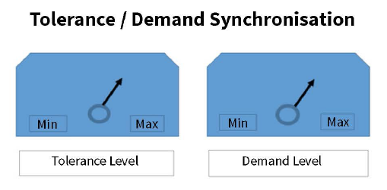Targeted intervention may also involve developing a tolerance/demand plan which reflects the window of tolerance theory described above. This is a plan which articulates the varying levels of anxiety the young person may experience, and the level of demand they are able to tolerate at each of these levels. A young person with high levels of tolerance at one moment in time, is likely to tolerate higher level of demands (and vice versa).

To achieve this, it is important to identify what a young person’s behaviour looks like when their anxieties are low, medium and high. Once this is known, the plan can include the types of demands/activities the young person can engage with at each level. Staff can then increase demands when tolerance levels are high and reduce demands when they are low. This approach identifies that flexibility above consistency usually achieves better long-term results. Please note that each individual is different, and each response will be different and so it is important to follow assess, plan, do, review cycle to evaluate strategies and approaches.

Please see an example co-regulation plan below.

| **Anxiety level** | **Presenting behaviours** | **Demands/activities tolerated** | **Co-regulation strategies** |
| --- | --- | --- | --- |
| Low | Steady heart/breathing rate. Calm state of arousal. Open to social engagement. Expressive facial expression and voice prosody. Able to listen, process language and engage. | The child can mostly undertake activities and demands within the classroom, with careful consideration of ways in which this is directed (following strategies above). | Maximise expressive social engagement. Fully engage and connect using the face, voice, movement. Encourage listening and expressive responses. Engage thinking skills to reflect and make connections. Introduce gentle challenge through play/activity |
| Medium | Slightly raised heart/breathing rate. Signs of agitation, frustration, anxiety. Raised hypervigilance. Lack of focus, easily distracted. Increased mobilisation. Early signs of needing to take control or helplessness. | The child needs a reduction in demands at this time, allowing for some time to regulate before increasing expectations again. | Attune to mood, intensity and energy of the child. Respond by being more animated to attune to agitation, increase intensity to attune to anger, be gentle and delicate to attune to sadness. Respond empathically and validate feelings. Use calming, and regulatory activities. |
| High | High levels of arousal/ distress. Hyper vigilant. Difficulty listening and focusing. Mobilised – fidgeting, jumping, running, climbing etc. Raised voice Oppositional behaviour. | Significant reduction in demands at this time (in a safe manner). | Reduce social demands whilst remaining present, convey adult containment by remaining regulated. Reduce language, give short clear directions. Use predictable routine. Reduce sensory input, lights, noise. |
| Crisis | The child’s behaviour means that they or other people are not safe. | No demands in any circumstances to be directed at the child at this time. | An individualised plan which outlines action to be taken in the event of unsafe behaviour. Adults to provide high levels of containment. |

## High level targeted/specialist support

Following the graduated response and multiple cycles of ‘assess, plan, do, review’, there may be a point of which external professionals will need to be sought to provide advice and guidance in meeting the needs of individual children. Cognus teams and services such as the Educational Psychology Service and the Autism Service can be requested as part of traded services. The Clinical Psychology Service can also offer a fully funded one-off consultation as part of the post-diagnostic support. It is important to note that therapeutic support for young people within this cohort is often made up of indirect support by external professionals so that key trusted adults working with young people in the environment can provide the intervention as this has been shown to have increased effectiveness.

Over the last six years, The Link School has been developing its PDA offer and currently meets the needs of pupils with a PDA profile at its primary site, secondary site, a dedicated PDA satellite site, as well as pupils in mainstream education. This provision is therefore available for children and young people with an EHCP where the primary presenting needs are in line with a PDA profile.  Going forward it is planned for placements at The Link Satellite Site to be time limited and to have a focus on intervention which reduces the anxiety of a young person and equips them with the skills required to make a supported return to a mainstream learning environment. The newly developed PDA Support Hub is an outreach offer which intends to extend The Link’s PDA offer to other families, agencies, special and mainstream schools so they can better understand and support this group of children to achieve positive long-term outcomes.

In addition, the [PDA society](https://www.pdasociety.org.uk/) is the only specialist PDA charity in the UK. Their goal is to try and make life better for young people with this profile and their families underpinned by a commitment to research underpinning every step in improving understanding, support and outcomes for PDA people in the future.

# Resources and links

Websites:

* The PDA Society is the only specialist PDA charity in the UK and provide information, training, and support to PDA people and their families.
* PDA society [enquiry line](https://www.pdasociety.org.uk/contact-us/enquiry-line/) for parents/carers and professionals.
* [Demand avoidance](https://www.autism.org.uk/advice-and-guidance/topics/behaviour/demand-avoidance) - NAS
* [Identifying PDA – PDA Society](https://www.pdasociety.org.uk/about-pda/identifying-pda/)
* Autism Education Trust
* [Demand-Avoidance-Vs-Pathological-Demand-Avoidance-PDA.pdf](https://www.esht.nhs.uk/wp-content/uploads/2021/07/Demand-Avoidance-Vs-Pathological-Demand-Avoidance-PDA.pdf)
* [Sandy-PDA-article-single-pages.pdf](https://www.ohcat.org/wp-content/uploads/2021/04/Sandy-PDA-article-single-pages.pdf)
* [S-Turner-article-in-Autism-Parenting-magazine.pdf](https://www.ohcat.org/wp-content/uploads/2021/05/S-Turner-article-in-Autism-Parenting-magazine.pdf)
* [Supporting-Parents-of-Children-with-Autism.pdf](https://www.ohcat.org/wp-content/uploads/2021/08/Supporting-Parents-of-Children-with-Autism.pdf)
* [diagnostic-centre@autismeastmidlands.org.uk](mailto:diagnostic-centre@autismeastmidlands.org.uk)

Books :

* ‘Understanding Pathological Demand Avoidance Syndrome in Children - A Guide for Parents, Teachers and Other Professionals’ by Phil Christie, Ruth Fidler etc.
* ‘The Teen’s Guide to PDA’ by Laura Kerbey and Eliza Fricker
* ‘Black Rainbow: A Gripping Family Drama About PDA the Journey to Self-discovery and Acceptance’ by Danielle Jata-Hall.
* ‘Pathological Demand Avoidance Syndrome: My Daughter Is Not Naughty’, by Jane Sherwin and Ruth Fidler.
* ‘Can I tell you about Pathologial Demand Avoidance Syndrome?’ by Ruth Fidler and Phil Christie.
* ‘The Red Beast’, by K.I. Al-Ghani
* ‘Starving the Anxiety Gremlin’, by Kate Collins-Donnelly.
* Bloggers - ‘Dinky & Me’, ‘Steph’s Two Girls’, ‘The Life of Duck’, ‘Understanding PDA’, ‘Dragonriko’ and ‘Me, Myself and PDA’.

# References

Gillberg, C., Gillberg, I. C., Thompson, L., Biskupsto, R., & Billstedt, E. (2015). Extreme (“pathological”) demand avoidance in autism: a general population study in the Faroe Islands. *European child & adolescent psychiatry*, *24*, 979-984.

Green, J., Absoud, M., Grahame, V., Malik, O., Simonoff, E., Le Couteur, A., & Baird, G. (2018). Pathological demand avoidance: symptoms but not a syndrome. *The Lancet Child & Adolescent Health*, *2*(6), 455-464.

Green, J., Absoud, M., Grahame, V., Malik, O., Simonoff, E., Le Couteur, A., & Baird, G. (2018). Demand avoidance is not necessarily defiance–Authors' reply. *The Lancet Child & Adolescent Health*, *2*(9), e21.

Hershler, A. (2021). Window of tolerance. *Looking at trauma: A tool kit for clinicians*, *23*, 25-28.

Kildahl, A. N., Helverschou, S. B., Rysstad, A. L., Wigaard, E., Hellerud, J. M., Ludvigsen, L. B., & Howlin, P. (2021). Pathological demand avoidance in children and adolescents: a systematic review. *Autism*, *25*(8), 2162-2176.

Moore, A. (2020). Pathological demand avoidance: What and who are being pathologised and in whose interests?. *Global Studies of Childhood*, *10*(1), 39-52.

O'Nions, E., & Eaton, J. (2020). Extreme/‘pathological’demand avoidance: an overview. *Paediatrics and Child Health*, *30*(12), 411-415.

Siegel, D. J., & Bryson, T. P. (2018). The yes brain child: help your child be more resilient, independent and creative. Simon and Schuster.