Why We Love Outdoor Kitchens in the Early Years
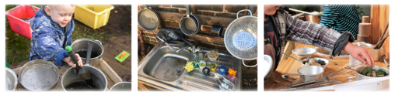
Have you ever seen the joy on a child’s face as they whip up a muddy “cake” or stir a “soup” made of leaves, water, and a dash of imagination? Outdoor kitchens are a big favourite— and it’s not just because they’re fun (though they definitely are!). These play spaces are packed with learning opportunities that support children’s development in so many ways.
Building Big and Small Skills
Whether children are scooping soil, stirring water, or pouring from one container to another, they’re giving both their fine and gross motor skills a fantastic workout. These everyday actions help strengthen little hands and arms, building coordination and control — all while having a brilliant time outdoors.
Language Comes to Life
Outdoor kitchens are perfect for sparking rich conversations and storytelling. As children role play, they naturally use new vocabulary and practise taking turns in conversation. “Would you like a cup of leaf tea?” can quickly turn into a back-and-forth full of giggles and imagination — and lots of lovely language development.
A Feast for the Senses
These sensory-rich environments invite children to explore the world around them. From the squish of mud between fingers to the fresh scent of herbs and flowers, outdoor kitchens offer endless opportunities to explore texture, smell, and sound — helping children make sense of their environment in a hands-on way.
Learning to Work Together
Perhaps one of the most valuable aspects of outdoor kitchen play is the way it supports social skills. Children learn to share tools, take turns, and work together to cook up their creations. They negotiate roles (“You be the chef, I’ll be the customer!”) and collaborate on ideas, laying the groundwork for positive relationships and teamwork.
What Do You Need for a High-Quality Mud Kitchen?
There’s something magical about a mud kitchen. Whether it’s a muddy muffin shop, a leafy soup café, or a stone-and-herb bakery, children love creating, mixing, and pretending in their own outdoor kitchen space. But what turns a few pots in the garden into a truly high-quality mud kitchen?
Here’s what we recommend to get the most out of this wonderful learning area:

🌿 The Essentials
Mud!
Let’s start with the obvious! Good, diggable mud is the star of the show. You can mix soil with a bit of water to get the right texture — not too dry, not too sticky.
A Worktop and Stove
This could be an old table, wooden crates, or even upcycled furniture. Having defined “cooking” spaces helps inspire role play.
A Sink
An old basin, washing-up bowl, or even a bucket can do the job. Adding a pretend or working tap adds an extra layer of excitement and realism!
Water
Whether it's from a watering can, jug, or hose, water is key for mixing, pouring, and making that perfect muddy consistency.
Pots and Pans
Old saucepans, frying pans, and baking trays make fantastic mud kitchen tools.
Sieves and Colanders
Perfect for exploring texture, separating leaves or stones, and adding an extra sensory element.
Jugs and Funnels
These encourage pouring skills and help develop hand-eye coordination and control.
Containers, Bowls, and Plates
Add variety to their play with different shapes and sizes — plastic, metal, or recycled kitchenware all work brilliantly.
Kitchen Utensils
Wooden spoons, ladles, whisks, and spatulas are perfect for stirring, scooping, and serving up muddy masterpieces.
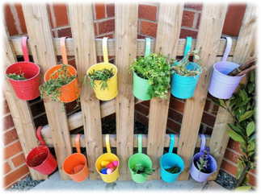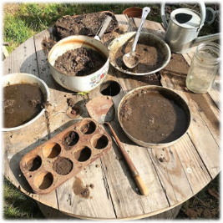

✨ Enhance Your Mud Kitchen With…
- Tongs, ice cream scoops, potato mashers – Great for fine motor development and imaginative role play.
- Pestle and mortar – Let children grind herbs, petals, and pebbles to create “magic potions” or secret recipes.
- Pine cones, pebbles, and natural treasures – These add texture, storytelling props, and creative ingredients.
- Scented herbs – Mint, rosemary, and lavender bring in lovely smells and open up sensory exploration.
- Recipe cards – Use picture-based or simple word cards to spark ideas and support early literacy.
- Chalkboards – Great for writing menus, prices, or just doodling while they cook!
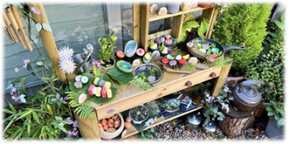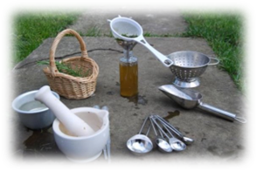
Setting up a mud kitchen doesn’t have to be expensive — many of these items can be collected second-hand, donated, or found in nature. What matters most is creating a space where children feel free to explore, imagine, and get their hands dirty!
So grab a wooden spoon, dig in the dirt, and let the mud pies begin!

