Sensory Circuits in the Early Years: Setting Children Up for Success
Supporting children’s self-regulation, focus and readiness to learn is a core part of early years practice. One increasingly popular approach is the use of sensory circuits—structured, short sensory-motor activities designed to help children feel settled, organised and prepared for the day. But what exactly are sensory circuits, and how can early years settings use them effectively?
In this blog post, we’ll explore how sensory circuits work, why they’re beneficial, and practical tips for introducing them in your early years environment.

What Are Sensory Circuits?
A sensory circuit is a simple, sequenced set of physical activities that help children regulate their sensory systems. Typically lasting 10–15 minutes, the circuit helps children:
- Wake up their bodies
- Improve body awareness
- Organise their sensory input
- Prepare their brains for learning
Sensory circuits are widely used for children who experience sensory processing differences (such as those associated with autism, ADHD or developmental delays), but they are beneficial for all children, especially in the early years, where movement-based learning is essential.

Why Sensory Circuits Work
Young children learn and self-regulate best when their sensory needs are met. Movement supports:
- Attention and focus – activating the vestibular and proprioceptive systems can help children settle for seated or group tasks.
- Emotional regulation – physical activity reduces stress and anxiety, supporting calmer behaviour.
- Executive function skills – circuits support impulse control, sequencing, motor planning and organisation.
- Overall wellbeing – starting the day with movement boosts mood and confidence.
In short: sensory circuits prime the brain and body for learning.

The Three Stages of a Sensory Circuit
A well-balanced sensory circuit typically follows three phases:

1. Alerting Activities
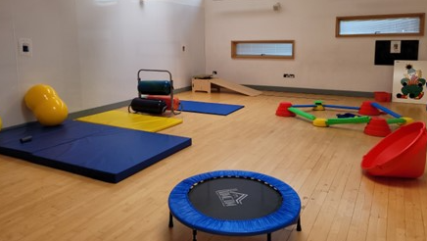
Helps children wake up their bodies and increase focus.
Examples:
- Jumping
- Star jumps
- Skipping
- Bouncing on a mini trampoline
These activities stimulate the vestibular system and increase alertness.

2. Organising Activities
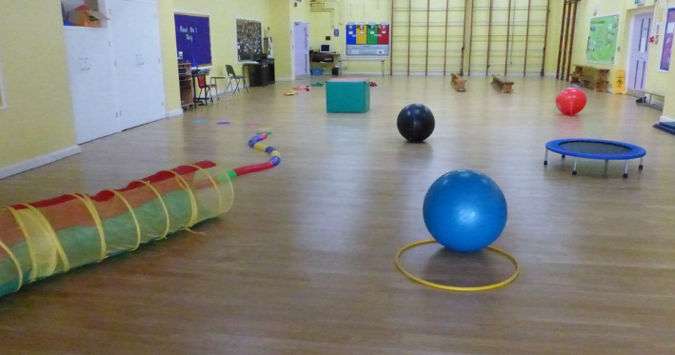
Require motor planning and sequencing—helping the brain organise sensory information.
Examples:
- Obstacle courses
- Target throwing
- Balance beams
- Crawling tunnels
This stage supports concentration, coordination, and problem-solving skills.

3. Calming Activities

Bring children back to a regulated state so they are ready to learn.
Examples:
- Deep pressure (e.g., pushing against a wall)
- Slow rocking
- Weighted or squishy items
- Breathing exercises
This stage ensures children transition smoothly into routines.

Sensory Circuits in Early Years Settings
Sensory circuits fit beautifully within EYFS practice because they:
- Can be integrated into morning routines
- Support children with additional needs
- Provide purposeful movement breaks throughout the day
- Promote independence and physical development
- Encourage turn-taking, social interaction and fun!
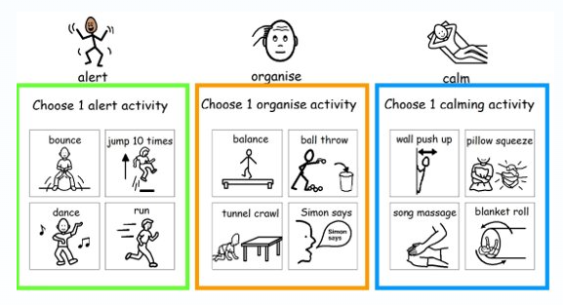

Tips for Setting Up an Effective Sensory Circuit
Here are some practical ways to embed sensory circuits successfully:
✔ Keep it short and consistent
10–15 minutes daily is ideal. Children benefit from routine and predictability.
✔ Use visual supports
Clear visual symbols (e.g., Widgit) help children understand expectations and sequence activities.
✔ Provide choice
Offering two alerting or calming options supports autonomy and regulation.
✔ Model the activities
Adults demonstrating each movement helps with clarity and engagement.
✔ Observe and adapt
Every child is different—tweak activities based on individual needs.
✔ Prioritise safety
Ensure space is clear, equipment is appropriate, and children are supervised.

The Impact: What Practitioners Notice
Early years practitioners often report:
- Improved readiness for learning
- Fewer behavioural dysregulation episodes
- Better engagement in group activities
- Boosted confidence and independence
- More settled transitions
Sensory circuits aren’t a magic fix—but they’re a powerful, evidence-informed tool to support the holistic development of young children.

Final Thoughts
Sensory circuits offer a simple, low-cost, high-impact way to support children’s wellbeing and regulation. In the early years—where movement, exploration and sensory experiences are essential—these circuits are a natural fit. With thoughtful planning and a consistent approach, you’ll soon see how this small routine can make a big difference to children’s day-to-day experiences.

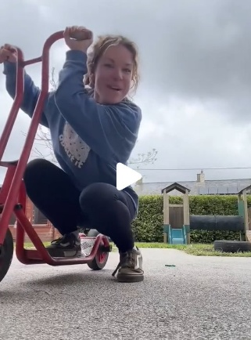
Resources

Sensory Class – Sensory Circuits
This SEND teacher has lots of great ideas to support children with additional needs. In this video she gives practical ideas for simple sensory circuits.

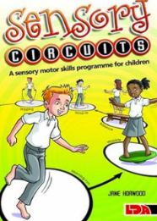

Sensory Circuits by Jane Horwood

https://www.nhsborders.scot.nhs.uk/media/1086579/CYP-OT-Sensory-Circuits.pdf
https://www.wyevalley.nhs.uk/media/679313/sensory-motor-circuits.pdf

