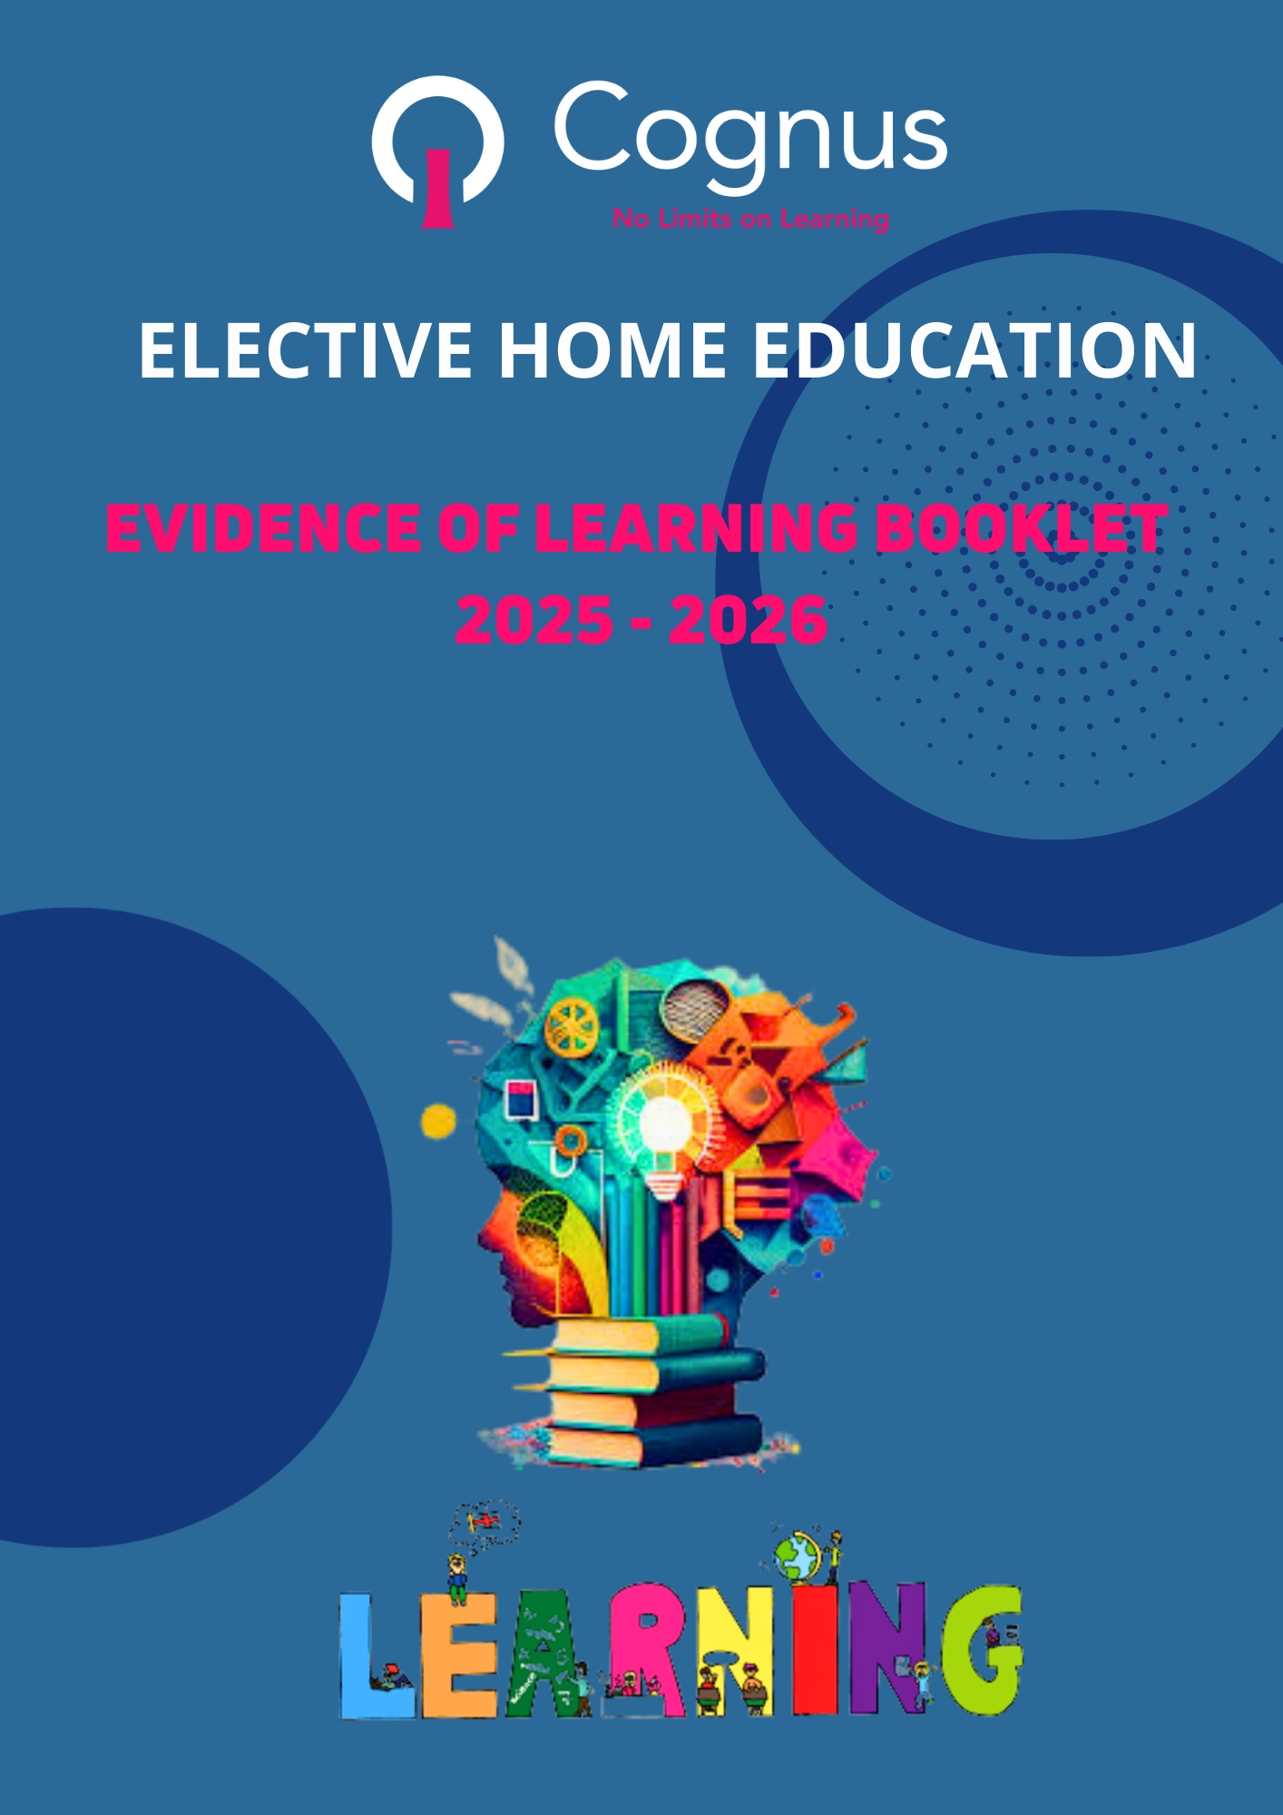

LONDON BOROUGH OF SUTTON

ELECTIVE HOME EDUCATION 2025 – CHILDREN WITH AN EHCP

PUPIL EVIDENCE OF LEARNING BOOKLET

PARENT / CARER DETAILS
PARENT/CARER NAME: |  | PARENT/CARER NAME:
RELATIONSHIP TO CHILD: |  | RELATIONSHIP TO CHILD:
ADDRESS: |  | ADDRESS:
PARENT / CARER RESPONSIBILITY: |  | PARENT / CARER RESPONSIBILITY:
YES NO |  | YES NO
ARE ALL PARENTS WITH PARENTAL RESPONSIBILITY IN AGREEMENT WITH EHE? Yes/No
If no, please give details.

HOME TEL NO: |  | HOME TEL NO:
MOBILE PHONE: |  | MOBILE PHONE:
EMAIL ADDRESS: |  | EMAIL ADDRESS:

CHILD DETAILS
CHILD’S FIRST NAME:
SURNAME:
PREFERRED NAME:
SCHOOL YEAR:
DATE OF BIRTH:
GENDER:
ETHNICITY:
CHILD’S ADDRESS (if different from parent/carer address)
POST CODE:
DOES YOUR CHILD HAVE SPECIAL  EDUCATIONAL NEEDS AND/OR A DISABILITY? |  |  | YES: |  |  |  |  |  | NO:
If yes, please provide further details.
DOES YOUR CHILD HAVE AN EDUCATION, HEALTH AND CARE PLAN (EHCP)? |  |  | YES: |  |  |  |  |  | NO:
DATE OF EHC PLAN:
DATE OF LAST REVIEW:

NAME OF EHCP COORDINATOR:
EHCP SECTION E:
PLEASE COMPLETE AND HIGHLIGHT HOW YOU ARE MEETING THE TARGETS SET OUT IN SECTION E OF YOUR CHILD’S EHCP.
DOES YOUR CHILD EAL? (ENGLISH AS AN ADDITIONAL LANGUAGE) |  |  | YES
 |  |  | NO
IS YOUR CHILD ON A CHILD PROTECTION PLAN? |  |  | YES: |  |  |  |  |  | NO:
If yes, please provide the name of your Social Worker/Early Help Worker:

IS YOUR CHILD ON A CHILD IN NEED PLAN OR HAVING SUPPORT FROM EARLY HELP? |  |  | YES: |  |  |  |  |  | NO:
If yes, please provide the name of your Social Worker/Early Help Worker:

PREVIOUS/CURRENT SCHOOL DETAILS
Has your child ever attended school? |  |  |  | Yes: |  |  |  | No:
1. Name of previous/current school:
Have you written to the school to notify them of your intention to home educate? |  |  |  | Yes/No
Please tick your reason for electing to home educate from the list below? (Please tick the most appropriate)
 | Reason for EHE | Tick here |  |  | Explanation and examples
 | 1 Physical Health |  |  |  | Child is EHE due to one or more physical health conditions e.g. autoimmune illness.
 | 2 Mental Health |  |  |  | Child is EHE due to one or more mental health conditions e.g. anxiety.
 | 3. Health concerns relating to Covid-19 |  |  |  | Child is EHE due to underlying health conditions which increase their, or a member of their families, risk of serious illness from COVID-19 or anxiety regarding COVID-19 transmission.
 | 4. Did not get school preference |  |  |  | Child is EHE as they did not receive their first choice of school preference and their parents were unhappy with any other option. This should be used in cases where it was the parent’s choice as opposed to there being no school place available, in which case ‘Difficulty in accessing school place’ should be used.
 | 5. Permanent exclusion |  |  |  | Child is EHE as they were permanently excluded from their previous school and parent did not want or get alternative education arrangements (e.g. alternative provision)
 | 6. Risk of school exclusion |  |  |  | Child is EHE as parents chose to remove the child from school before the child was excluded.
 | 7. Difficulty in accessing a school place |  |  |  | Child is EHE as there are no suitable school places available e.g. for geographical reasons such as moved home and no suitable school with available places or difficulty in accessing a school that meets the child's needs. This should be used in cases where there is no school place available, as opposed to the preferred choice not being available.
 | 8. Philosophical or preferential reason |  |  |  | Child is EHE as the parent prefers to home educate in order to follow child-centred, flexible approaches to learning instead of mainstream education, or parent feels their child is more suited to home education.
 | 9. Religious reasons |  |  |  | Child is EHE as their religious views were not compatible with the school ethos or curriculum  e.g. in regard to relationships and sex education.
 | 10. Lifestyle choice |  |  |  | Child is EHE due to their family’s lifestyle choice. This could be as their family travels regularly e.g. service children, Gypsy/Roma, Traveller of Irish heritage, child actors, circus performers etc.
 | 11. Suggestion/pressure from school |  |  |  | Child is EHE as they have been off rolled by the school e.g. to suggest home education for a child who is not attending school regularly, or behavioural needs are not being met at the school.
 | 12. General dissatisfaction with school – general |  |  |  | Child is EHE as they left their previous school due to general dissatisfaction e.g. unhappy with the curriculum of the school, ethos of the school, member of school staff etc.
 | 13. Dissatisfaction with school - SEND |  |  |  | Child is EHE as they left their previous school because their needs were not met or there was inadequate SEND provision.
 | 14. Dissatisfaction with the school - bullying |  |  |  | Child is EHE as they left their previous school because of bullying which was not resolved.
 | 15. Offered a school place but not yet accepted |  |  |  | Child is EHE as parents did not accept school place offered.
 | 16. Did not apply for a school place at compulsory school age |  |  |  | Child is EHE as parents did not apply for a school place at compulsory school age.
 | 17. No reasons given |  |  |  | The reason why child is EHE was not provided by parents or parents refused to give a reason.
 | 18. Other
 | 19. Unknown
EVIDENCE OF LEARNING
Please provide as much detail as possible about the home learning for your child, including examples of learning. We advise that you keep a comprehensive record of your child’s learning as we may request examples of learning to help support the assessment process.

Below are some examples of the types of evidence we look to receive in order to complete a thorough assessment of learning:
• A weekly timetable that you may have in place showcasing what learning looks, you can provide a brief description if this suits you better
• Social activities that your child benefits from: do they attend any clubs, team sports etc. You can write a brief synopsis of the opportunities that your child has to socialise with peers and/or make new friends etc.
• English – a list of resources that you use to support reading and writing. This could include the names of any books, website links, and equipment.
• Photo examples sent through showcasing English work completed by your child – writing, spellings, phonics etc.
• Math’s – list of resources that you are using to support math’s.
• Photo examples of completed pieces of math’s work.
* Information in relation to how you are supporting any special educational/learning needs for your child.
• Any other information that you feel may support the assessment process such as foundation subjects covered or life skills that your child is currently learning e.g., cooking, baking, gardening, swimming, art, likes/dislikes, reading books etc.

- Curriculum covered -

Subjects/areas and content covered:

Resources used to support the learning e.g. names of books, portals, websites used:

Who is the learning delivered by? Parents, carers, tutors, online portal etc.

- If you have a regular timetable, please complete the weekly planner below.

MON | TUES | WED | THUR | FRI | SAT | SUN

- If you do not have a regular schedule, approximately how many hours are involved in educational activities each week?

- If your child is currently in Year 11, what are their/your plans for their Post 16 destination?

- How will you know if your child is making progress? (for example, recording work completed, photographs, blog, video, journal, marking work, identifying milestones reached).

- Pupil voice: What are your child’s thoughts & hopes about being home educated? (they might want to include a drawing or some writing as age appropriate – we have attached some example worksheets if you prefer for your child to complete these)

- Environment: Describe the environment in which your child completes their learning e.g. desk, study room etc.

- Educational Visits – Describe any opportunities that your child has had to explore the local/wider environment to support their learning e.g. museum trips etc.

- Social Contacts/Physical Activity – describe the opportunities your child has to make new friends, socialise with peers, attend clubs etc.

Are you attaching examples of learning alongside this booklet? Yes or No
Are you familiar with the DfE Elective Home Education guidance for parents? Yes or No
Parent / Carer signature |  | Date
Thank you for completing the booklet detailing your child’s home education.

Please email to: ehe@Cognus.org.uk

or post to:
EHE team, Cognus, Cantium House, Railway Approach, Wallington, SM6 0DZ, England

