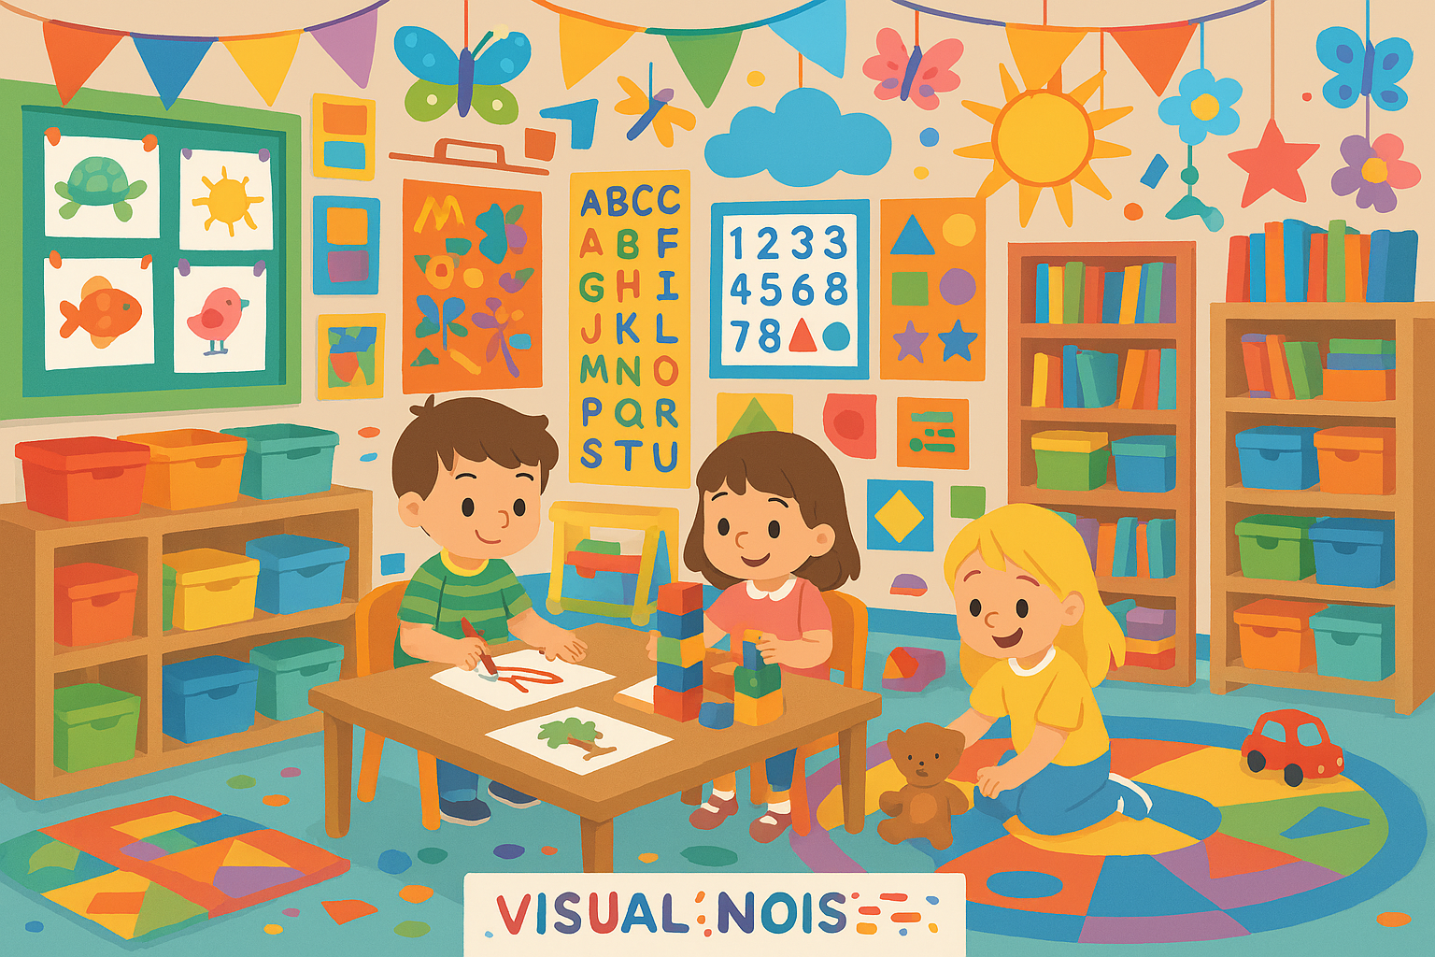-
🌿 Reducing Visual Noise in the Early Years Classroom
Creating Calm, Focused Spaces for Young Learners
Walk into an Early Years classroom on any given day and you're likely to find colour, creativity, and children bustling with energy. But while a lively environment can be wonderful, it can also overwhelm young learners when visual clutter takes over.
Reducing visual noise isn’t about stripping the classroom bare—it’s about being intentional. A thoughtfully designed space supports attention, emotional regulation, and independence. Here's how to strike the balance.

✨ Why Visual Noise Matters
Young children are still learning to filter sensory input. When a room is visually busy—full of posters, bright colours, hanging displays, and overflowing shelves—their brains work harder just to process what they see.
Too much visual clutter can lead to:
- reduced attention and listening
- difficulty with transitions
- increased stress or overexcitement
- challenges with focus during tasks
- less effective learning environments
A calmer classroom helps children feel safer, more organised, and better able to engage in meaningful play.

🧩 Strategies to Reduce Visual Noise
1. Simplify Your Colour Palette
opt for:
- neutral or soft tones for walls and furniture
- a few accent colours for key learning areas
Neutral backgrounds help children focus on the learning materials rather than the room itself.

2. Limit Displays—and Make Them Purposeful
Instead of filling every wall space:
- display only what supports current learning
- use bulletin boards for student work, not commercial posters
- keep displays uncluttered, spaced out, and easy to read
Ask yourself: Does this display help children learn—or is it just filling a gap on the wall?

3. Tidy the Environment with “Visual Rest” Spaces
Visual rest means giving the eyes somewhere calm to land—small pockets of blank or minimally decorated space.
These areas:
- reduce cognitive overload
- make the room feel calmer
- improve the visual impact of your intentional displays
Try leaving one wall or corner largely free from decoration.

4. Reduce Overloaded Shelves
Young children don’t need access to everything at once.
Try:
- rotating resources every few weeks
- storing extras in labelled bins away from open shelves
- using baskets and natural materials to soften the look
Fewer choices = deeper play.

5. Use Closed Storage Wherever Possible
Cupboards, curtains, and boxes hide clutter and reduce stimulation. Open shelving is fine for key resources that children can access, but too much visibility of stored items can overwhelm little learners.

6. Be Intentional with Hanging Displays
Mobiles, bunting, or hanging crafts can be beautiful—but too many can create visual chaos.
Limit hanging items and ensure they:
- serve a purpose (e.g., sensory mobile in a reading area)
- are placed thoughtfully, not everywhere

7. Create Clear Zones for Learning
Use furniture placement, rugs, or subtle signage to define areas such as:
- construction
- role play
- small-world
- reading corner
Clear zoning reduces wandering and helps children understand expectations.

8. Involve Children in Classroom Organisation
When children help arrange materials or decide what goes on display:
- they take ownership of the space
- they become more independent
- the environment feels calmer and more familiar

🌱 The Impact of a Calm Classroom
Teachers often notice immediate changes when visual noise is reduced:
- children settle more quickly
- behaviours improve
- focus increases
- the classroom feels more welcoming
- adults feel less stressed too!
A calmer environment supports everyone in the room.

🧘‍♀️ Final Thoughts
Creating a visually calm Early Years classroom doesn’t mean eliminating creativity or warmth. It simply means approaching the environment with care and intention. When we reduce visual noise, we give children the gift of clarity, focus, and emotional ease—allowing them to learn, play, and thrive.

