Why Do Young Children Bite?

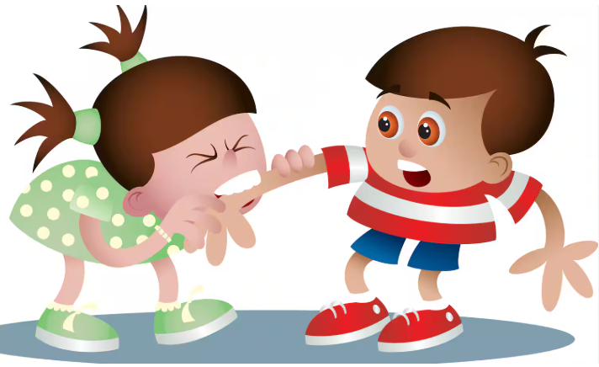
Biting can be challenging for any early year's setting. A calm play session can quickly turn into a situation involving strong emotions, worried children, and concerned parents. It’s important to remember that biting is a common and developmentally normal stage for many young children. Most children between one and three will experience a biting phase, and with sensitive, consistent support, they will move past it.

Understanding the Reasons and Supporting Positive Behaviour

Children bite for a range of reasons and understanding why a child may bite is crucial for their emotional and social development.

- Exploration and curiosity
Babies and young children investigate the world through their mouths by biting to explore texture, cause and effect and sensations.

- Comfort
A child may seek closeness and oral comfort at the same time, leading to biting during a cuddle.

- Communication Difficulties
Biting can be a way to express frustration when verbal skills are still developing.
Children may bite because they have no other effective way to communicate their needs such as what they want or to ask for help.
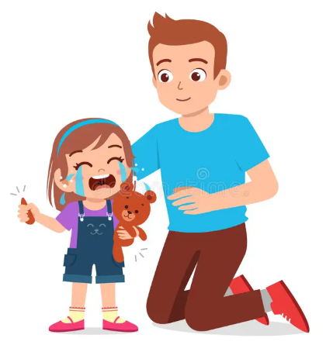
- Emotions
An impulsive reaction when overwhelmed with big feelings such as excitement, anger, frustration or jealousy. Children may bite if their space feels invaded or if a toy is taken.

- Attention Seeking
A negative reaction is sometimes better than nothing. A strong adult reaction can unintentionally reinforce the behaviour.

- Teething
Teething discomfort can make biting feel soothing.

- Change
Transitions such as starting nursery, moving home, illness, or the arrival of a new sibling can increase anxiety and lead to biting.

Understanding the “Why”
If the biting is not a one-off incident, look for patterns to identify the triggers. Does it happen when they are tired, over excited or hungry? Are there specific times of the day or scenarios when it happens?

What to Observe
- When does the biting occur?
- What happens beforehand?
- Who is involved?
- How often does it happen?
- What does the child bite?
- What is the immediate response?

Practical Strategies for Settings
Below is a broader range of strategies you can use to reduce biting and support children to develop safer, more functional skills.

If teething, provide safe alternatives
- Offer chewable items (e.g., teething toys or safe sensory chews).
- Provide crunchy or chewy snacks at regular intervals.

Strengthen communication skills
- Model simple key phrases: “My turn”, “Help”, “Stop”, “No thank you.”
- Use gestures, visual prompts, or sign-supported communication to reduce frustration.
- Give children choices to increase their sense of control.

Reduce frustration triggers
- Limit waiting times and provide duplicates of high interest toys.
- Add turn taking supports such as timers or simple “waiting” baskets.
- Prepare children for transitions with clear cues (verbal countdowns, visual prompts).

Support emotional regulation
- Use co regulation strategies such as sitting close, offering deep pressure, or modelling calm breathing.
- Create a calm area where children can reset.
- Name emotions simply: “You’re cross,” “You wanted the toy,” “That felt too busy.”

Create predictable routines
- Keep routines consistent and clearly signposted.
- Warn children in advance of any predictable changes.
- Use short, simple explanations to help them understand what’s happening next.

Teach social boundaries
- Model gentle interactions such as “soft hands”.
- Practise personal space with games like “bubble space” or “my space / your space.”
- Reinforce positive peer behaviour immediately: “Good asking,” “Kind hands,” “Great waiting.”

Reduce environmental stress
- Ensure play spaces are not overcrowded.
- Offer quieter zones for children who become overwhelmed.
- Observe group dynamics and adjust staffing or activities accordingly.

Respond calmly and consistently
- Stay neutral and avoid large reactions that may reinforce the behaviour.
- Focus on supporting the child who was bitten.
- Briefly address the behaviour: “Biting hurts. You can chew this instead.”

Plan ahead for known patterns if you’ve identified triggers:
- Position an adult nearby during high risk moments (e.g., tidy up time, busy group play).
- Modify routines that regularly lead to frustration.
- Provide pre-emptive sensory input when you know a bite is likely (e.g., before transitions).

Work in partnership with parents and carers
- Share observations and strategies regularly.
- Agree on consistent responses across home and setting.
- Reassure families that biting is a developmental stage and will improve with support.

Monitor and review
- Track incidents using brief ABC-style notes (Antecedent–Behaviour–Consequence).
- Review patterns weekly to identify changes or new triggers.
- Adjust strategies as the child’s skills and needs develop.

In summary:
Biting can be upsetting for everyone involved, but it is often a normal part of early childhood development rather than a deliberate act of aggression. By taking time to understand the reasons behind the behaviour, observing patterns, and responding calmly and consistently, practitioners can help children develop safer ways to communicate their needs and manage their emotions. With patience, supportive relationships, and effective partnership working with families, most children move successfully through this stage, building the social, emotional and communication skills they need to thrive.

When to get help
While biting is a common developmental phase for many young children, there are times when additional advice and support may be needed. If biting persists over a prolonged period, increases in frequency or intensity, results in significant injury, or does not respond to the strategies being put in place, it is important to explore the underlying reasons in more depth.
Practitioners should also consider seeking further support if the child appears to be experiencing ongoing difficulties with communication, emotional regulation, sensory processing, or social interaction that may be contributing to the behaviour.
Working alongside parents, health visitors, early years SEND advisers, or other relevant professionals can help to build a fuller understanding of the child's needs and ensure that appropriate support is provided at the earliest opportunity.
Seeking help is about understanding their behaviour as communication and ensuring they receive the support they need to feel safe, understood, and successful.

